Weekly Focus | Write | Say | Make | Do  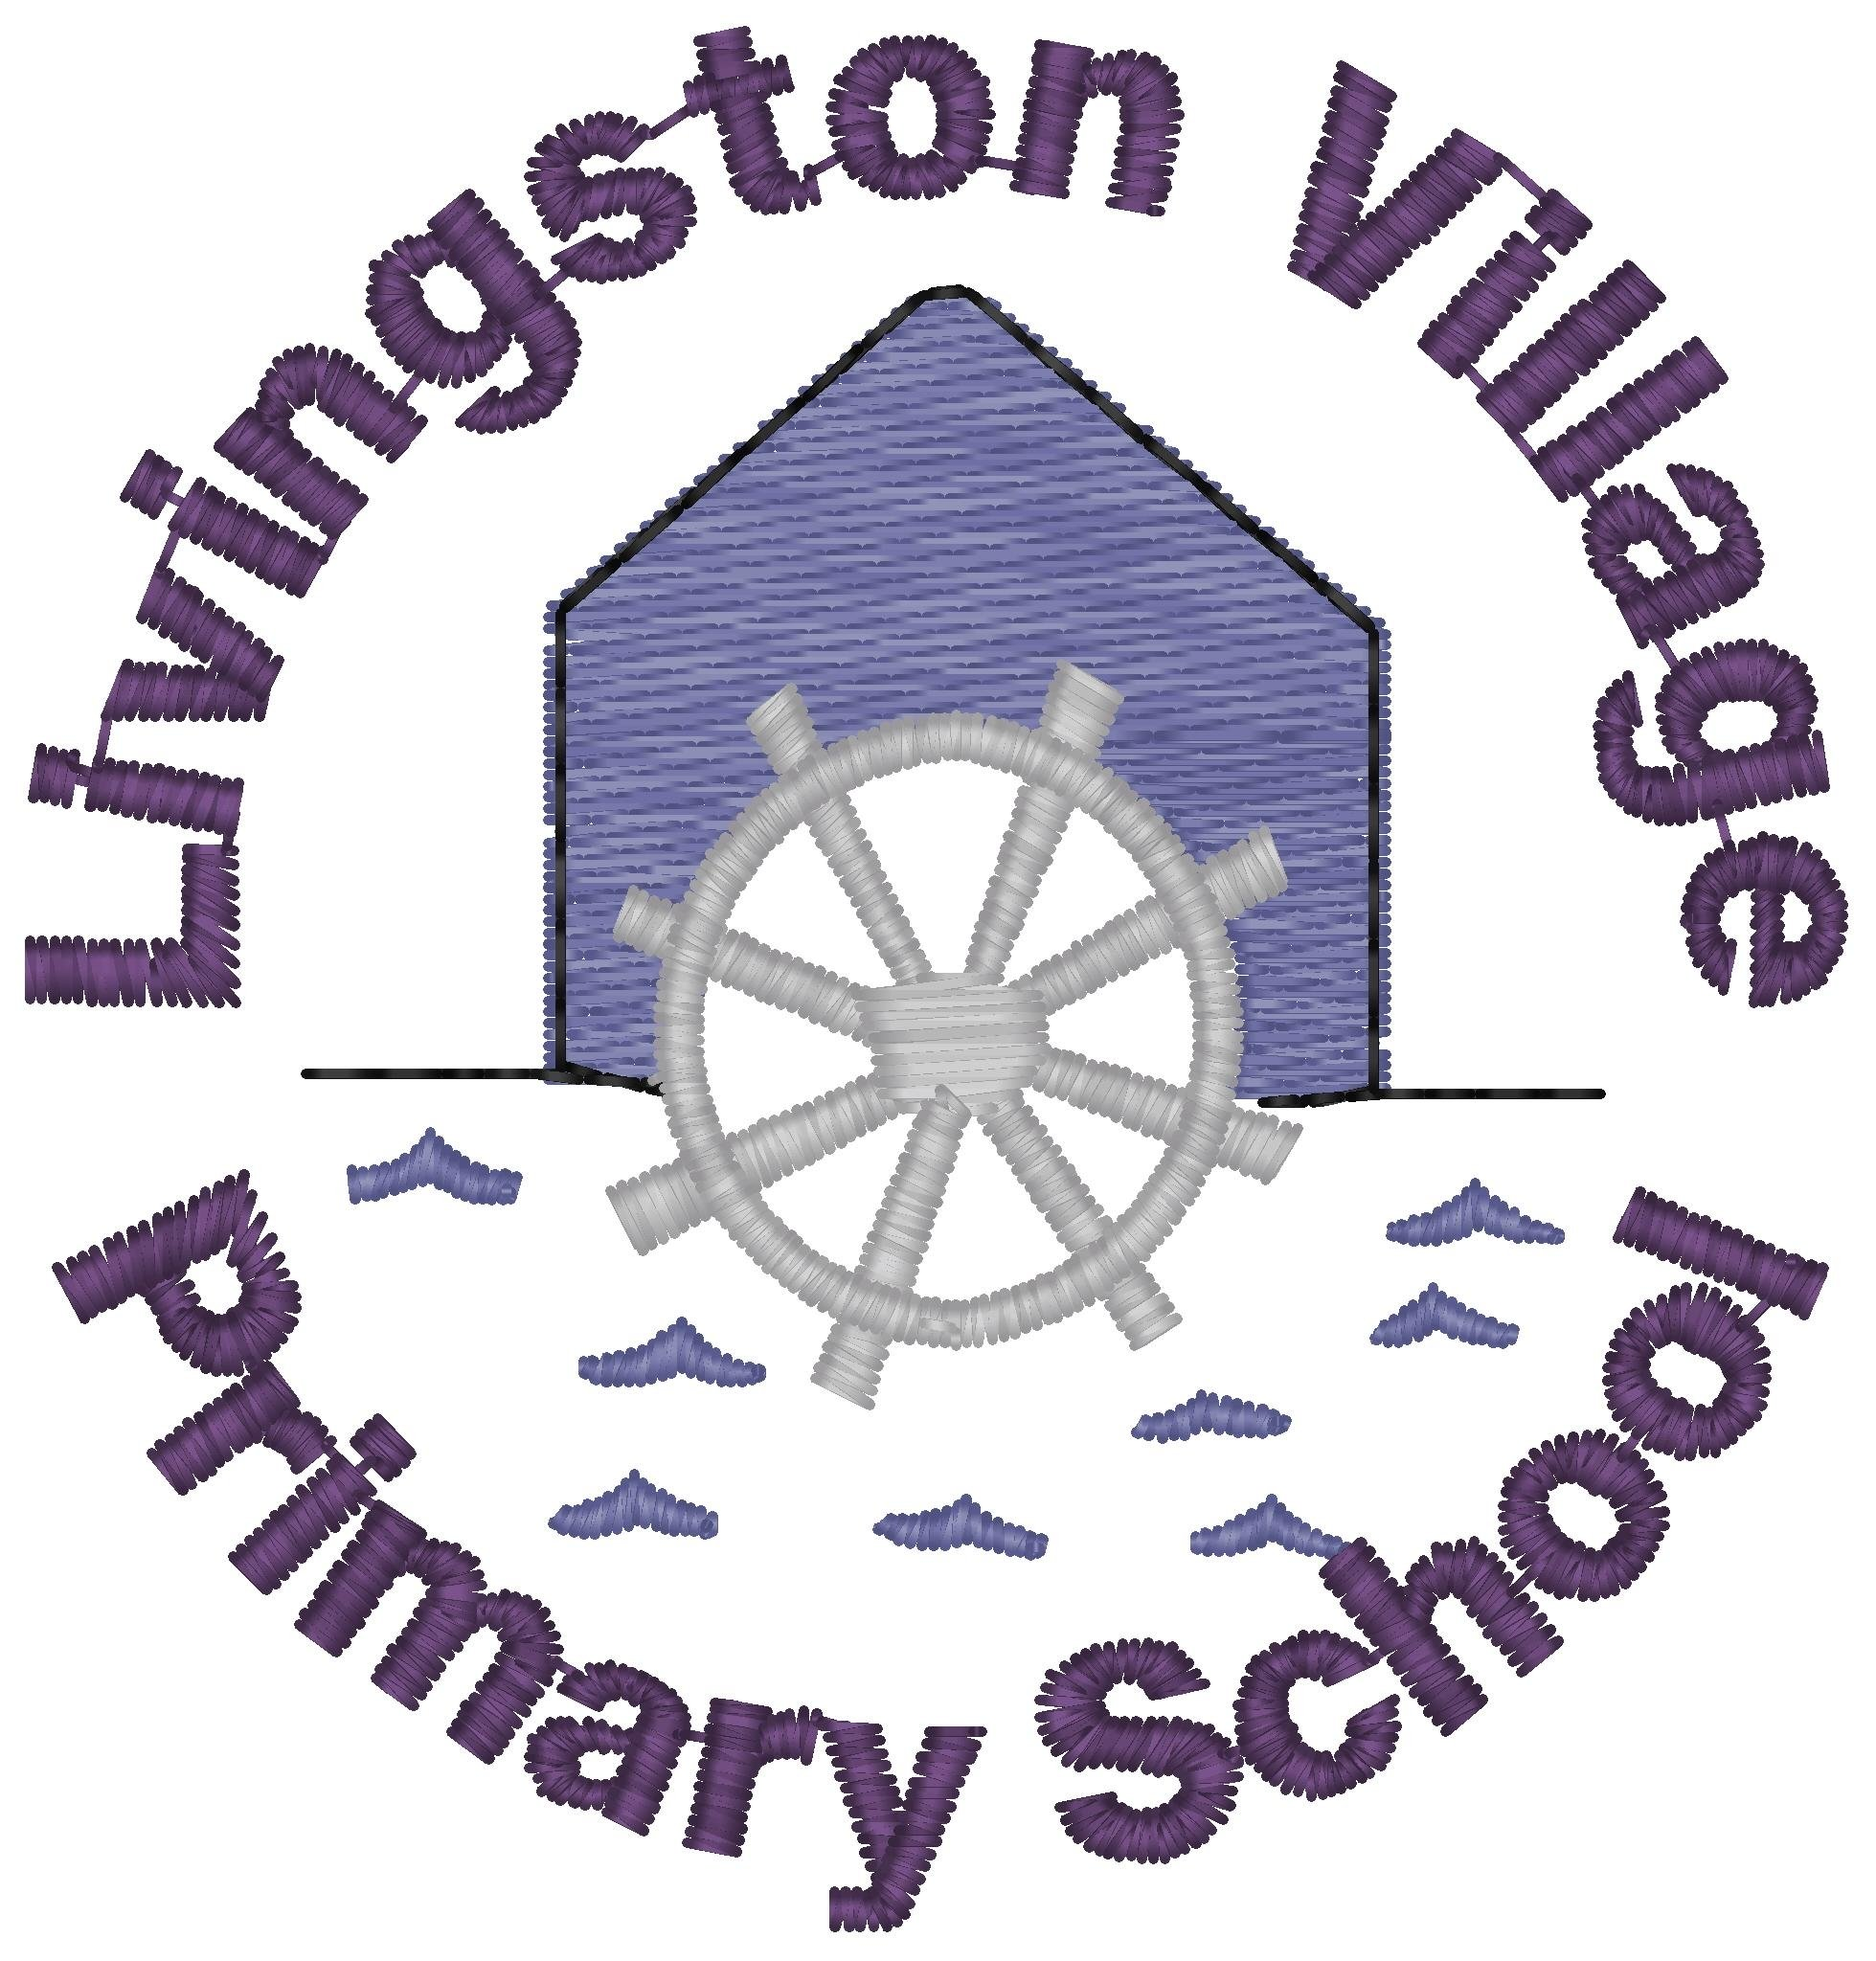
Sound: ew  Tricky Word: watch  Spelling Words  grew  stew  blew  threw  crew  drew  chew  flew  Maths: Length – explore using non-standard units to measure how long something is. Use the vocabulary long/short, longer/shorter, longest/shortest | Read ‘ew’ phoneme spotter postcard together with an adult. Can you write your own postcard or story using your ‘ew’ spelling words? How many of the words can you include?  Can you include the tricky word too? | Using the ‘ew’ buried treasure activity sheet say each word and if it is a real ‘ew’ word add it to the treasure chest or if it is a nonsense ‘ew’ word add it to the bucket. How much treasure did you find? | Make some playdough (see attached recipe) and create your spelling words in 3D. | Play this game  https://games.galacticphonics.com/longvowels/ew/interactive/game/index.html
 | Using small items (paper clips, buttons, coins) measure some objects from around your home and compare their lengths. Write some sentences, for example, The pencil is 6 buttons long. The scissors are 9 buttons long. The scissors are longer. | We want to know how big these footprints are, what can we use to measure them? Explore measuring them using small objects such as buttons – talk about how big each footprint is.  Perhaps draw your own footprints. | Build some models out of Lego, playdough or recycling materials and make them different sizes – compare them, looking at longest, shortest etc. | Outside in the garden or in front of your house draw around your shadow, your sibling’s shadow, mum and dad’s shadow – measure the longest, shortest etc. using hand spans, your feet or small toys
Quote of the Week   | Write a fact file for a creature of the sea. You can choose an animal from the pdf files or create your own using the blank template.  Here is a clip that introduces some animals and fish that might interest you.  https://www.youtube.com/watch?v=Fn4bQI6yiTk | Food chains  Read through the Under the Sea Food Chains powerpoint with your family and talk about what you find out. | Draw a picture of a shark or an Orca. Using just 3 colours. | Under the Sea Food Chains Sorting Activity.  Can you choose some animals and put them in the correct order to show who eats who in the food chain?

