Follow the instructions for each day. There are no rules. Just use your imagination.

Day 2
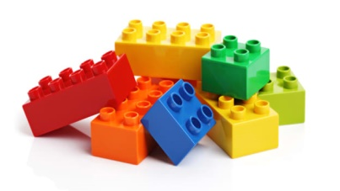
NASA needs you to build a new rocket.
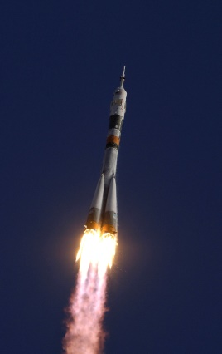

Don’t forget to share your photos with us.

