Weekly Focus
New spelling patterns and word lists have been emailed to all P2 parents  Maths: I can add and subtract within 20. I can use my number bonds to help me. I can solve worded problems.  https://whiterosemaths.com/homelearning/year-1/  Reading:  https://www.getepic.com/  P2 class code: xrd6728  https://www.oxfordowl.co.uk/  Class username/login:  p2reads  lvps | Spelling  Choose one of the spelling cards each day to help you learn your spelling words.  Extra challenge  Can you write a poem using as many of your spelling words as possible? | Grammar  An adjective is a describing word. Adjectives describe an animal, person, thing or thought.  Have a look at this video: https://youtu.be/IT-G4c2-CHU  Have a go at this worksheet.  ..\Adjectives.docx  Challenge: Can you think of an adjective for every letter of the alphabet | Reading  Continue to use EPIC! Or Oxford Owls for reading.  Reading activity: Pick a book and after reading it write a book review. Did you enjoy it? Would you recommend it to others?  ..\t-l-1069a-book-review-writing-frame-editable-version_ver_1.doc | Writing  Following on from our Spring adventure story, work with a grown up, use a dice and the My Fairy tale storyboard..\us-t-2549090-fairytale-storytelling-dice-game-english-united-states_ver_1.pdf to create your own stories. Can you write your story down so you can share it with others?
 | Lesson 1: Add by making 10  Watch the video  https://whiterosemaths.com/homelearning/year-1/  Complete the attached worksheet. | Lesson 2: Subtract within 20  Watch the video  https://whiterosemaths.com/homelearning/year-1/  Complete the attached worksheet then check your answers. | Lesson 3: Add and subtract worded problems  Watch the video  https://whiterosemaths.com/homelearning/year-1/  Complete the attached worksheet and then get an adult to check your answers | Lesson 4: Compare number sentences  Watch the video and complete the attached sheet  https://whiterosemaths.com/homelearning/year-1/  Friday’s Maths Challenge  https://whiterosemaths.com/homelearning/year-1/
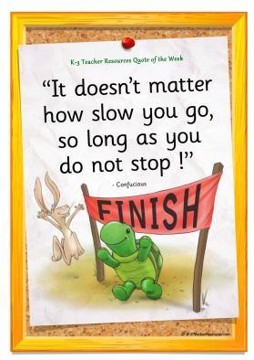  Quote of the Week | Poem  Can you write a poem from the work you did last week?  Here is a template to get you started.  ..\I can see under the sea poem template.docx | Meal time chat – talk to your family about where you live and what makes it a good place to live. Think about where you get your food, water, and where work or school is, where your friends are. How would you feel if you lived in a desert? | Make an under the sea picture with the collage materials you collected.  Will it be a coral reef/ deep ocean/ sand bed or a seaweed (kelp) habitat?  What creatures are you going to have in your picture?  What plants grow in the sea?  What creatures live in that habitat? | Habitat is the name for the neighbourhood we live in.  See if you can sort the creatures into their habitats on the work sheet. Can you add any of your own?  ..\Under the sea - Habitats.docx

