Who lives where?
Can you sort the fish into their habitats?
You can print then cut and stick, take a photo and send in. Or, you could move into place on computer, save and send in.
Sand bed | Coral reef | Deep sea | Seaweed

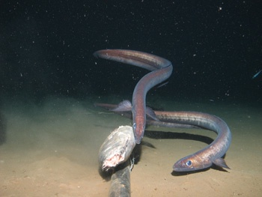  eels | 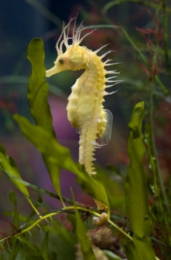  seahorse  eels | 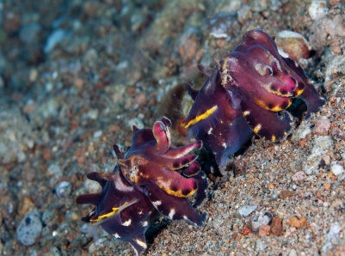  cuttlefish | 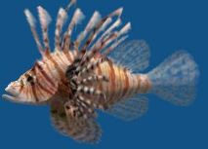  lionfish
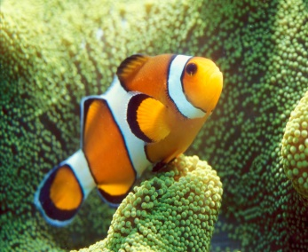  clownfish | 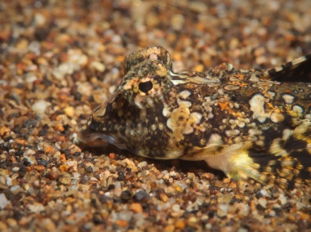  dragonet | 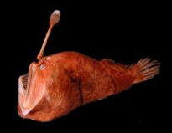  angler fish | 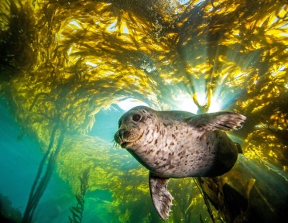  sea lion  sea lion
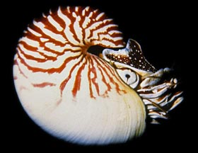  nautilis | 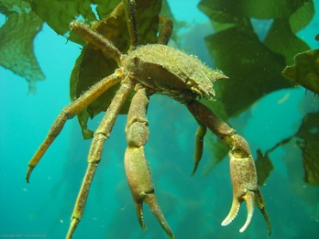  spider crab | 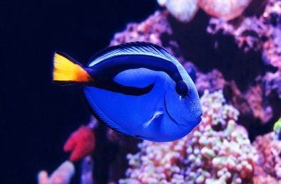  blue tang fish | 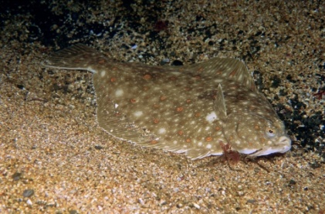  plaice fish
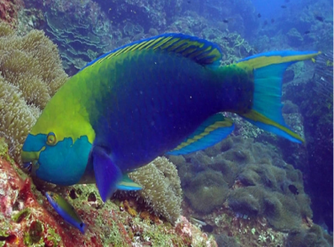  parrot fish | 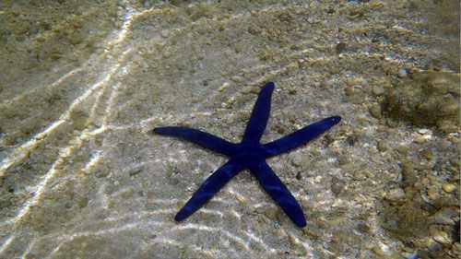  star fish | 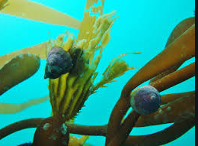  snails | 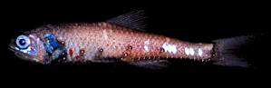  lantern fish

