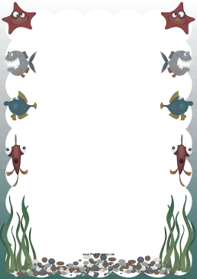
I Can See Under the Sea

I can see____________________

I can hear____________________________

I can touch____________________

I am feeling _____________________

and _________________

I am amazed by___________________

I am scared of____________________

But I am glad_____________________

______________________

By ___________

