Weekly Focus | Write | Say | Make | Do  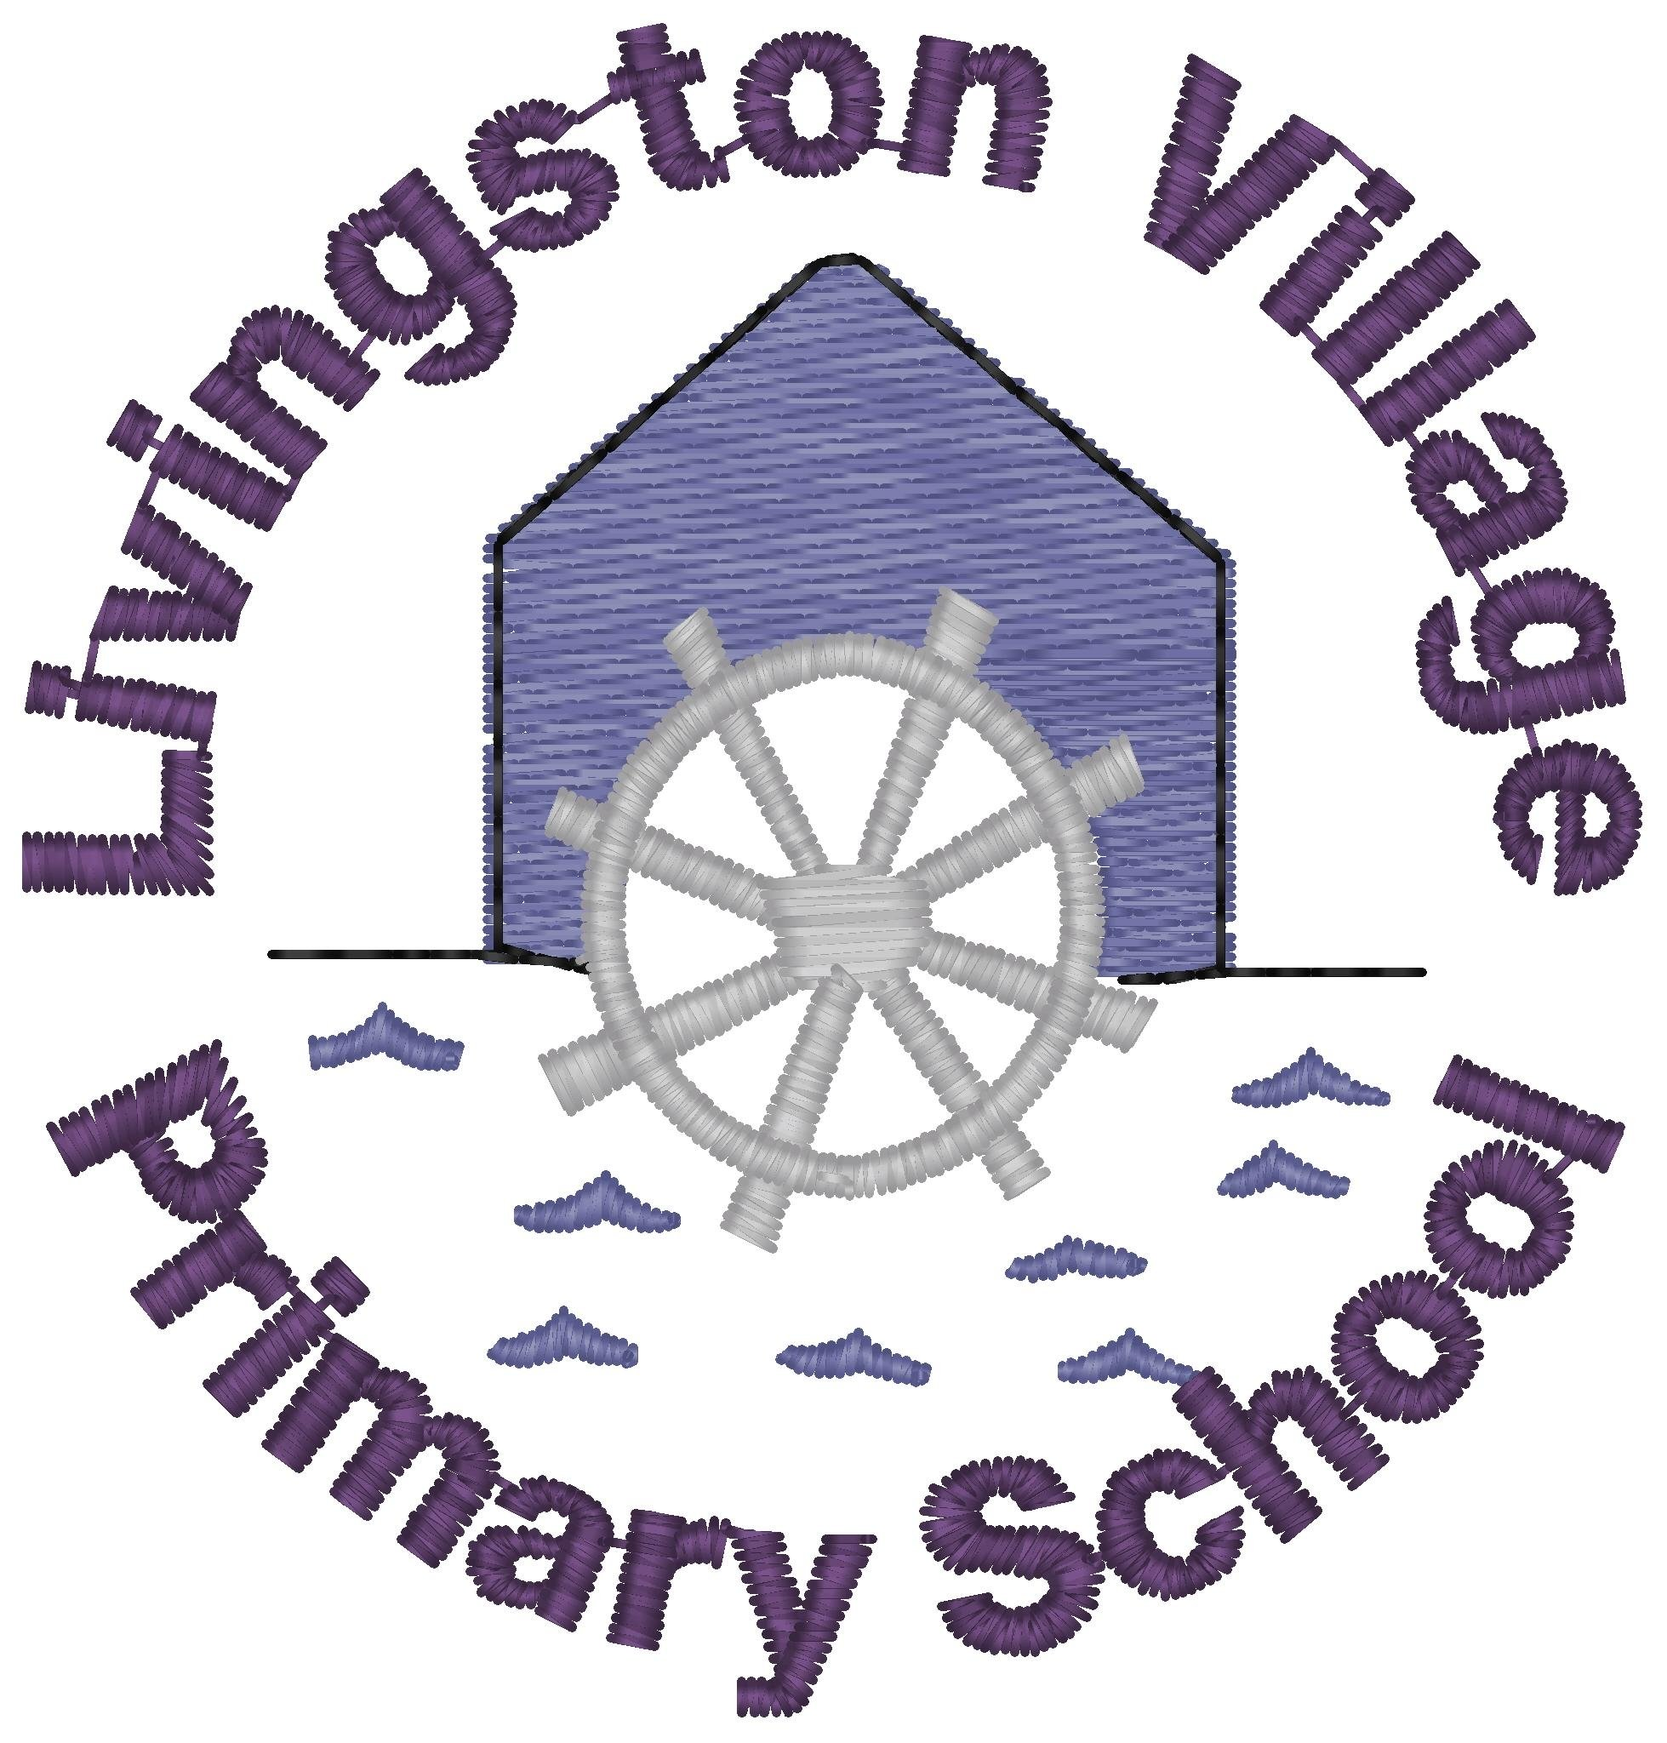
Sound: oa  Tricky Word: here  Spelling Words  goat  boat  road  cloak  throat  roast  coal  coach  Maths: Time – Revision of o’clock and half past times using both analogue and digital clocks | Practise writing this week’s sound (oa), spelling words and tricky word (here) using your finger in the mud, in sand or in shaving foam. | Read the story of Wendy the Witch (attached powerpoint) aloud to a grown up. How many words did you say that contained the ‘oa’ sound?  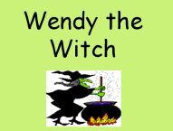 | Draw and colour a picture. Hide the ‘oa’ sound words in your picture. Show your picture to an adult. Can they find your hidden words? | Real and nonsense ‘oa’ words activity sheet.  Read each word aloud; put it in a sentence. If it makes sense it is a real word, if not it is a nonsense word. Colour real words one colour and nonsense words another or write them using different colours if you don’t have a printer.
 | Digital and Analogue Clocks O’Clock and Half Past worksheet | Sing along with Jack Hartmann in this fun clock song https://www.youtube.com/watch?v=tEmg914-9xY | Find items from around your home to make your own clock. Put the hands at different times and talk about what time it is. | Play What’s the Time Mr Wolf? in your garden
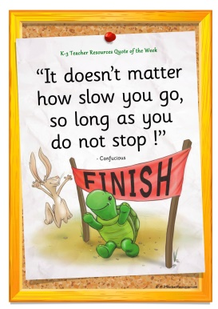  Quote of the Week | Poem  Can you write a poem from the work you did last week?  Here is a template to get you started. | Meal time chat – talk to your family about where you live and what makes it a good place to live. Think about where you get your food, water, and where work or school is, where your friends are. How would you feel if you lived in a desert? | Make an under the sea picture with the collage materials you collected.  Will it be a coral reef/ deep ocean/ sand bed or a seaweed (kelp) habitat?  What creatures are you going to have in your picture?  What plants grow in the sea?  What creatures live in that habitat? | Habitat is the name for the neighbourhood we live in.  See if you can sort the creatures into their habitats on the work sheet. Can you add any of your own?

