Weekly Focus
Spelling pattern – ea  Spelling Words  peach  teach  speak  cheat  dream  team  please  year  Maths: Fractions – to recognise, find, name and sort halves and quarters | Choose one of the spelling cards each day to help you learn your spelling words.  Extra challenge  Can you write a letter to a friend or family member using as many of your spelling words as you can? | Nouns are naming words. They can be names of people, places or things. Look around your house or garden or when you are on a walk and write down all the nouns that you can find?  Worksheet attached in blog post. | Choose a book on Epic! and read it. Can you recount the main events of the story in your own words and tell them to an adult.  https://www.getepic.com/ or download the app  Classroom code to access Miss Maclachlan’s class: egh0733 | Following on from our Superheroes stories work with a grown up, use a dice and the Roll A Spring Adventure Story activity sheet (attached) to create your own stories. Can you write your story down so you can share it with others?
 | Look at the PowerPoint Halves and quarters. Complete the worksheet: Sort halves and quarters | As well as finding halves of shapes you can find halves of amounts. Using small toys or counters or buttons have a go at finding half of numbers to 20.  Worksheet(Optional): Fractions of amounts | Pizza ingredients activity – Use the templates of a pizza and ingredients and follow the instruction cards to make different pizzas showing halves and quarters | Check out Sumdog for this week’s challenge.
Quote of the Week | Thank you for your applications, congratulations you have the job.  Write or phone someone to tell them your exciting news. | Meal time chat - Talk to your family what is the most important of these three things.  - Finding out about the sea creatures and sea.  - Looking after the sea creatures and sea.  - Telling others about the sea creatures and the sea.  Follow the link and let us know your decision https://forms.office.com/Pages/ResponsePage.aspx?id=oyzTzM4Wj0KVQTctawUZKeU_rOVKTnxFs5Aoaw5NfDhUME5GODI5U0M2MTVQWDlVRVJKNkNORE9FNS4u | Do you want to make a scuba outfit? Have you a swimming mask/ bottle/string or ribbon…  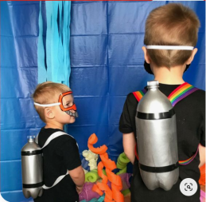 | As we learn about the sea please keep all your work together. Use or make a folder, or keep it together some where safe.  If you would like to make some sea animal masks then there are print off sheets here. If you do not have a printer then copy the picture onto some card and make.

