Weekly Focus | Write |  | Say | Make | Do  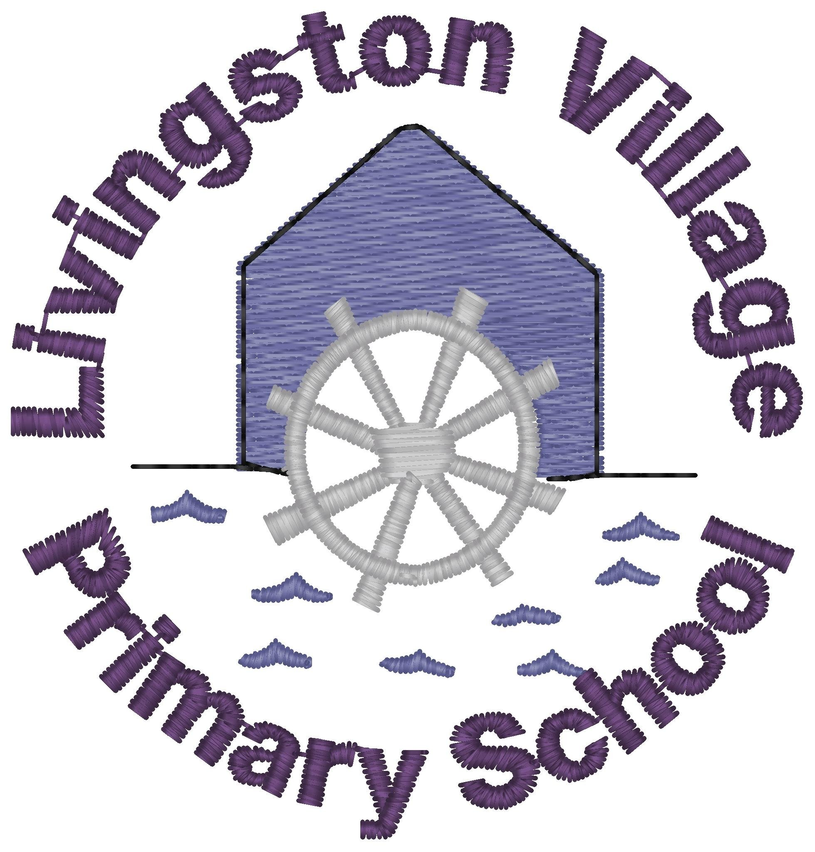
Sound: er  Tricky Word: two  Spelling Words  better  letter  over  never  after  litter  herb  corner  supper  perm  Maths: money - recognising all coins to £2 | Practise writing this week’s spelling words by creating a ‘er’ sound flower. Write a spelling word on each petal. A template has been provided but feel free to draw your own flower. |  | Reading ‘er’ Words Card Game  Play the game and say the words. Perhaps you could time yourself. Play against another player, who is fastest to say the words? | Make a word search using the attached grid or the following link https://thewordsearch.com/maker/ (please note the word search will be created in capital letters – a good opportunity to revise the link between lower case and upper case letters) | Play roll and read using a dice and some counters or buttons. Roll the dice, look at the number, find that row on the grid and read the word in the box. If you can read the word you can cover it with your counter. Can you cover all the words?
 | Coin rubbings  You will need some crayons, paper and coins. Lay out some real coins. Place a piece of paper over the coins. Pick up a crayon and rub over the coins. Once you have made your coin rubbings can you label each coin? |  | Identifying Change  Write some price tags up to the value of 20p. Lay them out on the table face down. Pick one and then say how much change you would receive if you bought an item costing this amount. Can you say which coins you would receive? | Play Kim’s Game  Lay out some coins on a tray, some ‘heads’ up and some ‘tails’ up. Take it in turns to close your eyes while the other person removes a coin. Can you tell which coin is missing? | Watch an Elmo video about money.  https://www.sesamestreet.org/toolkits/save
Quote of the Week  Keep up the great work everyone! | Thank you for your applications, congratulations you have the job!  Write to someone telling them your exciting news. | Meal time chat - Talk to your family what is the most important of these three things.  - Finding out about sea creatures and the sea.  - Looking after sea creatures and the sea.  - Telling others about sea creatures and the sea.  Follow the link and let us know your decision https://forms.office.com/Pages/ResponsePage.aspx?id=oyzTzM4Wj0KVQTctawUZKeU_rOVKTnxFs5Aoaw5NfDhUME5GODI5U0M2MTVQWDlVRVJKNkNORE9FNS4u |  | Do you want to make a scuba outfit? Have you a swimming mask/ bottle/string or ribbon…  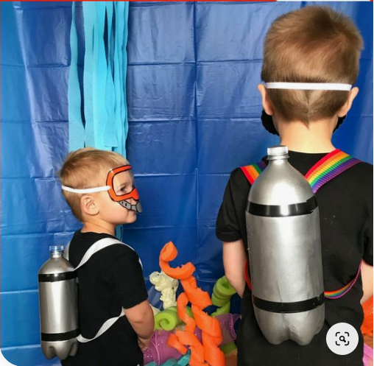 | As we learn about the sea please keep all your work together. Use or make a folder, or keep it together somewhere safe.  If you would like to make some sea animal masks then there are print off sheets attached. If you do not have a printer then copy the picture onto some card and make.

