Marine Biologist
Job Application

*Write here
*
Name:_________________________ Date:_________________
Colour box
Can you swim? Yes No

Do you like the sea? Yes No
Can you scuba dive? Yes No
Why do you want to learn about the sea? ______________________________________________________________________________________________________________________
*
*
What sea creature would you like to study?
*
___________________________________________________________
What do you already know about that animal?
*
_________________________________________________________________________________________________________________________________________________________________________________
*
*
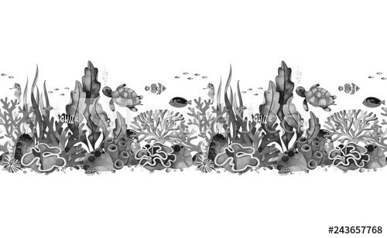
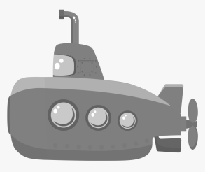
You can fill this in on the computer, save and return by email. Or you can print, write, take a photo and return by email.

