Weekly Focus
Spelling pattern – ee  Spelling Words  feed  feel  heel  bleed  three  sheep  queen  cheek  Maths: Fractions – to recognise, find, name and sort halves and quarters | Choose one of the spelling cards each day to help you learn your spelling words.  Extra challenge  Can you put each of your spelling words into a sentence? | We use capital letters and full stops every week in writing. Can you correct the punctuation in the sentences on the worksheet?  Worksheet attached in blog post. | Choose your favourite book and read it.  Can you recount the main events of the story in your own words and tell them to an adult.  Draw a picture of your favourite part of the story and write a couple of sentences to explain the part of the story you have illustrated. | Let’s learn the days of the week in French. Listen to the song and sing along  https://www.youtube.com/watch?v=Lpwf5N0rfVE  Can you find all the days of the week in the word search attached in the blog post?
 | Go to https://whiterosemaths.com/homelearning/year-1/  Mon: complete Find a Half(1)  Tues: complete Find a Half(2)  Wed : complete Find a quarter (1)  Thurs: complete Find a quarter(2) | Give the children different shapes and sizes of bits of paper. Ask them to investigate what happens when they fold these bits of paper in two. Cut down their fold, how many parts do they now have? Introduce the idea that they have two halves. | Get the children to help make the sandwiches e.g. Lay out four pieces of bread and ask them how many slices needed for one sandwich (2 slices). Identify that they have just found a half. Repeat with the other ingredients. Once the sandwich is made ask them to halve/quarter it. | Play roll a fraction see attached sheet  or  play the whole half or quarter game on Snappy Maths
Quote of the Week  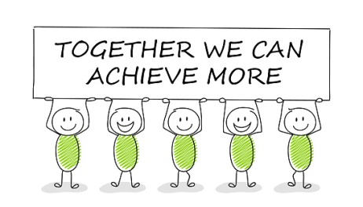 | Please complete and return the Application for Marine biologist by next week. | Meal time chat - Talk to your family how many sea creatures can you think of, can you think of one for each letter of the alphabet? | Make a list or draw a picture of the things you might need if you were going to learn about the sea. What would you need to keep you safe at sea? | Start collecting some collage/junk materials for art work. Colour in the map and name the oceans in the world. https://www.youtube.com/watch?v=dk8zDjQT0aE

