Weekly Focus | Write | Say | Make | Do  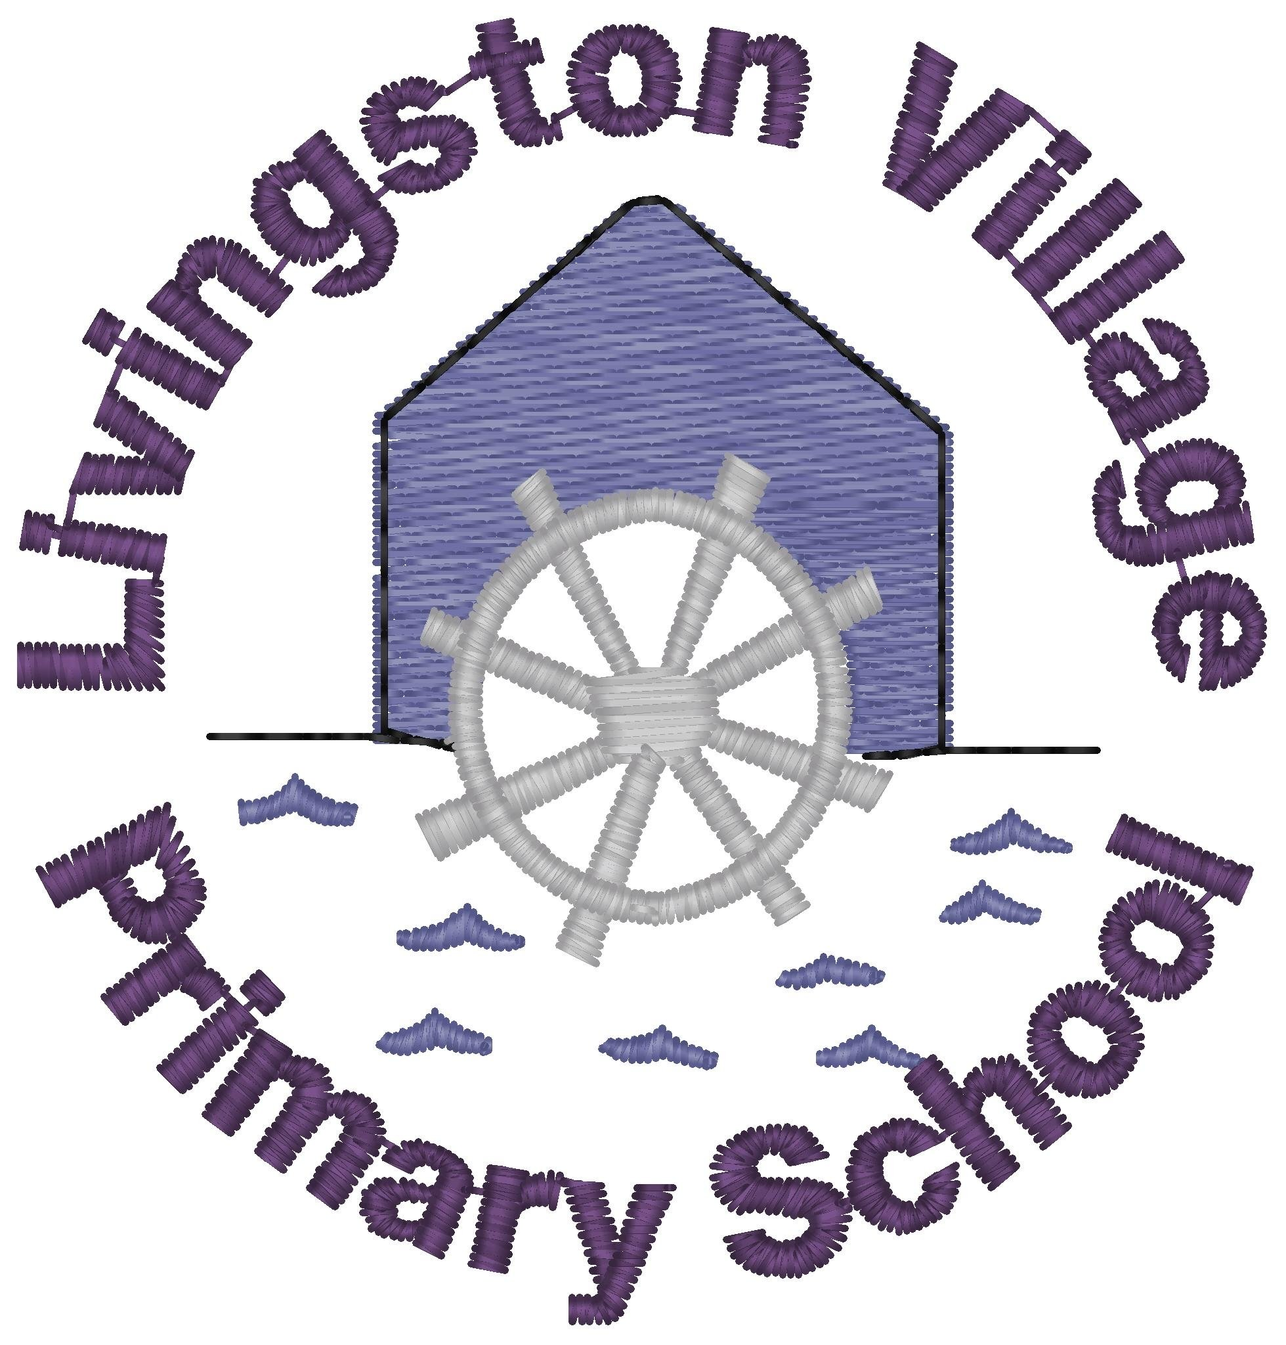
Sound: ur  Tricky Word: too  Spelling Words  fur  burn  curl  hurt  lurk  turn  burst  nurse  purse  slurp  Maths: money - recognising all coins to £2 | Practise writing this week’s sound (ur), spelling words and tricky word (too) using your finger in the air, on the carpet or on the back of someone. | Using the ‘ur’ Piggy Bank activity sheet, say each word and add each word containing an ‘ur’ sound to the piggy bank. How many coins did you add? Can you think of any more words you could add? | Make a Mystery Bag by putting in a picture for each of your spelling words (you could draw these or find pictures of them). Now take turns to pull out a picture and give clues for the others to guess which word you have. | Read Sam the Cat story and see how many ‘ur’ sounds you can find.  Pick one of your own books, can you find any ‘ur’ sounds in it?
 | Look at some real coins. Which ones do you recognise? Discuss their values.  Now complete the coin recognition labelling activity sheet. | Have a coin hunt around your house. Look at the different coins and assign them their name. Talk about colour and shape of the coins too. | Create a role play shop using toys and other things from around your house. All items in the shop are given a price below 10p at first. The children play shopkeeper which will help them learn the value of the coins and start to give change from 10p at first. | Play the following game from Topmarks  https://www.topmarks.co.uk/money/coins-game
Quote of the Week | Please complete and return the Application for Marine biologist by next week. | Meal time chat - Talk to your family how many sea creatures can you think of, can you think of one for each letter of the alphabet? | Make a list or draw a picture of the things you might need if you were going to learn about the sea. What would you need to keep you safe at sea? | Start collecting some collage/junk materials for art work. Colour in the map and name the oceans in the world. https://www.youtube.com/watch?v=dk8zDjQT0aE
We look forward to sharing in the children’s learning and hope you will be able to send us evidence of one literacy, one maths/numeracy and one topic task each week. Please email these to us at the end of each week and we will provide some feedback for your child. Emails can be sent to individual teachers or via the school office on wllivingstonvillage-ps@westlothian.org.uk.

