Livingston Village PS - STEAM
Missing STEAM in school? Here are some websites where you can take part in games, join in activities (both online and offline) and carry out investigations. Some sites use Flash so using laptops or netbooks is best.
Website |  | Notes
https://www.nasa.gov/kidsclub/index.html#.VIWzXzHF-So |  | A great website to learn how to build a rocket and other terrific games and activities.
https://pbskids.org/cyberchase/ |  | Join the cybersquad and take part in a wide range of games and activities including maths and coding
https://www.pbslearningmedia.org/collection/zoom/ |  | Lots of games, activities and downloadable offline activities to do.
http://www.kineticcity.com/ | 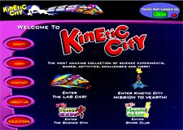 | For budding scientists. Enjoy games, activities and investigations. (needs Flash)

