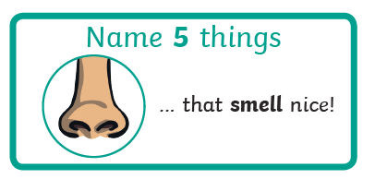
A different type of challenge for you today. Have a think about the following and discuss with your family.

