Design your own Easter Egg
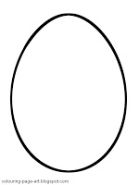
Design your own Easter egg. You can use paint, pen, pencils or crayons. Remember to make it colourful!

