Number Processes  Practise counting forwards and backwards to 50 using the following link to help you. https://www.youtube.com/watch?v=YtNskltyA0E  Practise saying some number sequences between 1 and 50, for example, 13, 14, 15, 16. Can you say which number comes next?  What about giving a sequence with a number or two missing, ie. 27, 26, 25, _, 23, 22, _, 20 | Addition and Subtraction  Practise counting items up to 20.  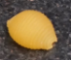  Use any items from around your home (ie. pasta shapes) to count two sets of objects. For example: | Mental Maths  During the past few weeks we have been practising our number bonds within 10. Here’s a good game to give you more practise, click the addition carriage then choose ‘Bonds to Make 10’  https://www.topmarks.co.uk/maths-games/mental-maths-train  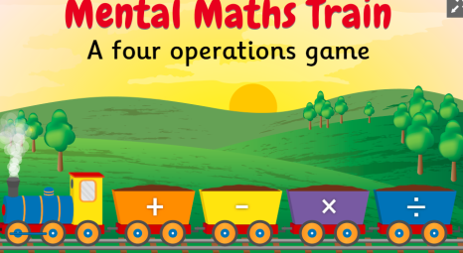
Time  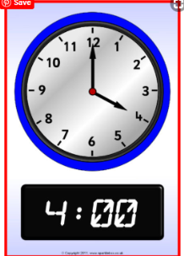  Make your own analogue clock face and use it to practise o’clock and half past times. Can you remember how to write those times on a digital clock? Here are some video clips to help you remember what o’clock and half past look like on both types of clock:  https://www.youtube.com/watch?v=EIxaxnageTo and  https://www.youtube.com/watch?v=8w1MgXz_uZg | Fractions  We have been learning about halves and quarters. Can you find examples of halves and quarters around your home?  Try playing this game:  http://www.snappymaths.com/counting/fractions/interactive/halfquartersimm/halfquartersimm.htm  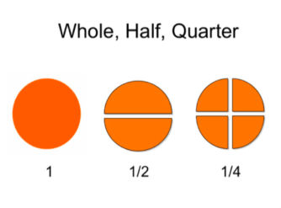 | Shape  We have been learning about 2D and 3D shapes. Use the following link of Gecko’s Garage to consolidate your learning:  https://www.youtube.com/watch?v=uedfyfO0gdw  Now go on a shape hunt around your home.  Can you name all the different shapes?  Are some shapes harder to find than others?  Why do you think this is?

