Phonics and Spelling  Revise all set 3 sounds learned so far.  ea – eat, tea, neat, real, clean, please, leave, dream  oi – spoil, join, coin, voice, noise, choice  a-e – make, cake, shake, name, same, game  i-e – nice, smile, shine, white, fine, wide, like, mine  o-e – phone, home, hope, rose, spoke, note, broke  u-e – huge, brute, tune, rude, mule, June, dude, use  aw – yawn, dawn, saw, raw, straw, crawl, claw  are – care, share, dare, bare, spare, scare, flare  ur – nurse, purse, lurk, turn, hurl, slurp, hurt  er – over, better, never, after, litter, supper, corner  Practise spelling this term’s tricky words; many, any, one, anyone, some, come, where, were, too, two using your sound cards or writing them out in different colours?  Then make a sentence with each word. | Reading  This is our last week of learning before the Easter holidays so let’s learn about the Easter Story.  Watch it here https://www.youtube.com/watch?v=0PSgoPdKQFQ  Can you recount the main events of the story in your own words and tell them to an adult.  Draw a picture from the story and write a sentence to explain the part of the story you have illustrated.  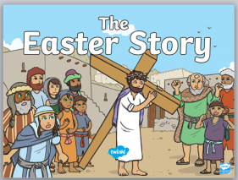 | Listening and Talking  This week we were going to be listening to some personal talks and I would still love for these to go ahead, it would be a great way to cheer up a family member. Choose your favourite animal and do some research to help you prepare a one minute talk to share with someone over the phone. Perhaps an adult could film your talk and you could send it to me at wllivingstonvillage-ps@westlothian.org.uk so I could hear it too!?! My favourite animal is the tiger, perhaps I could make a talk to send back to you?
Grammar  We have been learning about nouns and verbs. Remember nouns are naming words and verbs are doing words.  Watch these clips to remind yourself of each:  Nouns - https://www.youtube.com/watch?v=PDMk0XrQvV4  Verbs -  https://www.youtube.com/watch?v=DEfDk4zfTTo  Make some sentences, can you identify the noun and verb in each sentence? | Writing  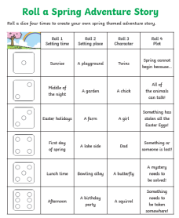  Working with a grown up, use a dice and the Roll A Spring Adventure Story activity sheet to create your own stories. Who can make the best story? Can you get some help to write your story down so you can share it with others? | French  Let’s learn the numbers 1-10. Listen to the song https://www.youtube.com/watch?v=lsc3qLMaCu8 and sing along. Can you use your fingers to count up and down in time with the music?  