10 nature activities for kids if you're self-isolating at home
We're all going to be spending a lot more time at home in the coming weeks and months due to the coronavirus crisis. With schools now closed, we know many families are looking for ideas to keep children entertained. To help, we've pulled together some simple, nature-based activities you can enjoy together at home or in your garden.
If you're not self-isolating, you can also get some exercise in your local wood. But please don't travel unnecessarily and always follow the Government's social distancing advice to keep yourselves and others safe. Take a look at our ideas for family fun in the woods.

1. Go on a minibeast hunt
Spring is well and truly kicking in now, and the warmer weather will bring lots of creepy crawlies out. So get your kids out in the fresh air and take a closer look at your garden. You'll soon notice it's teeming with wildlife! Can you find...
- a worm after a spring shower
- a bumblebee looking for nectar
- a spotty ladybird exploring the grass
- a slimy snail in a dark damp spot
- a butterfly basking in the sunshine?

2. Make a loo roll bird feeder
This is messy fun kids will love to get stuck into. And it will help them learn about the birds in your neighbourhood.
You can make this simple feeder with items you probably already have at home:
- Smother a cardboard tube in peanut butter (no added salt and sugar versions are suitable for birds).
- Roll it in bird seed and thread some string through the hole.
- Tie it up in your garden where birds will feel safe eating.
How many garden birds will you spot? Take a look at our blog to help you and your children identify them. https://www.woodlandtrust.org.uk/blog/2019/03/10-garden-birds/
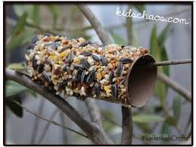

3. Go on a scavenger hunt
This is a fun idea for kids of all ages. You can keep it really simple for little ones - help them look out for different colours or textures in nature. For older children, challenge them to hunt for seasonal signs such as spring blossom or new leaves. Or ask them to see how many tiny natural objects they can find to fit inside a matchbox.

Spring scavenger hunt
In spring, nature starts to wake up from its long winter sleep. Trees burst into leaf, flowers cover the ground and animals emerge from hibernation. There’s so much to see, can you find…
- new green leaves
- scented blossom
- springy moss
- sticky leaf buds
- a lichen-covered twig
- a piece of eggshell (stay well away from bird nests, look for fragments of shell that have fallen to the ground)

Tree id app link - https://youtu.be/8aY5pjqq-wE

4. Make natural art
Art and crafts will be a popular way to keep kids busy. To mix things up, put the pencils and crayons to one side and look for natural art materials instead. Collect fallen leaves, petals and sticks and use them to make a picture or sculpture.
You could even use the objects as 'stampers' or paintbrushes - dipping them in paint and rolling, brushing or stamping them on paper to create interesting patterns.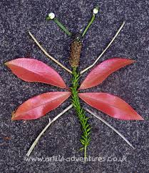.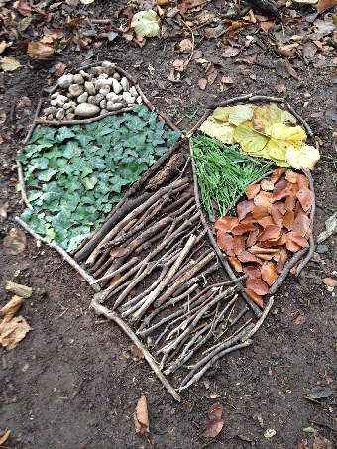 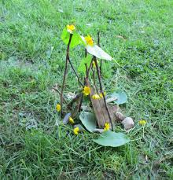

5. Have a picnic in the garden
Kids will soon tire of sitting around the same table for every meal, so pack up your lunch and take it outdoors. It's a lovely way to keep mealtimes varied, and for everyone to get some fresh air.
If you don't have a garden or it's raining outside, have an indoor picnic on the living room floor instead. Kids will love the change from the norm and it will feel like an adventure.

6. Move like minibeasts
This is a great way to get young children active and help them burn off some excess energy. You can do it outdoors or inside. Challenge your kids to:
- lie on the ground and wriggle like a worm
- flap their arms like a butterfly flutters its wings
- put their hands on the floor and scuttle about like a spider
- do some giant leaps like a cricket
- crawl on the floor then curl up into a ball like a woodlouse.

7. Make an animal or forest out of Lego
Many families will have Lego, wooden blocks or other building toys at home. So challenge your kids to make something inspired by nature. You could all work together to make one big scene, like a springtime woodland or a giant tree. Or you could have a contest to see who can build the best minibeast, mammal or bird.

8. Butterfly symmetry art
This craft has the wow factor! All you need is paint and some paper. Simply splodge paint on one half of your paper and fold it in half so the paint spreads on both sides. Carefully open it up to reveal a beautiful butterfly.
It's a great way to teach youngsters about butterflies and how their wings are symmetrical.
Once dry, your butterfly will make a cheerful decoration for your home. Or you could even turn it into a card to send to a grandparent you won't see for a while.
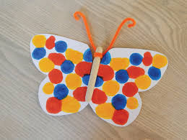

9. Ladybird potato stamps
Who doesn't love a cheerful ladybird? This fun activity is great for little ones. You just need a potato, paints and paper.
Watch our video to see what to do then get creative. You can even experiment and make other creatures like bumblebees, woodlice or shield bugs.
https://youtu.be/SXZvmdE0BNI

10. Write a story inspired by woods and trees
If your kids love writing, then get those creative juices flowing with a story challenge. Kick things off by giving them the first sentence and encouraging them to write the rest of the story.
You could also jot ideas on scraps of paper, then get kids to choose some at random that they have to incorporate into their story. These could include:
- A tree has fallen in the woods
- A character has gone missing
- An animal is shouting an alarm call
- There are some mysterious footprints to follow.
Gather together as a family and share the stories you've written. They'll make great bedtime stories too when you've read all the books you have at home.

