Numeracy  Pick a number between 5-20. How many part-whole models can you complete for your chosen number? | #FreeWriting  Have a go at writing a genre of your choice. This could be a letter, a poem or a story. | Phonics  What do I do?  You should complete at least 3 tasks but you can do more if you want to. We will be discussing our home learning in class time so you do not need to hand in completed tasks. Just be prepared to share your learning on  Thursday 12th December.  Self-Assessment Traffic Lights  When you complete a task colour the circle to show how you felt about it. If you don’t have the colours just write  R-A-G.  Red – I found this challenging.  Amber/Yellow – I needed some help.  Green – I’m confident.  Please remember that if you need paper or other resources to complete a task, ask the teacher!  Make a spelling poster showing all the words you know with these sounds:  - ur  - er  - ow (Brown cow)  - ai (snail in the rain)  - oa (goat in a boat)  - ew (chew the stew)  - ire (fire fire)
Read for Enjoyment  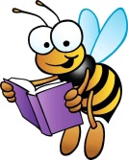  Pick up a book, comic or any other text and spend some time reading for enjoyment. Write down the title and author so you can keep track of everything you have read. Would you recommend it to a friend? | Science  Observe a starry night with your parents. Perhaps look for different constellations and draw a picture of them.  or  Observe and record how the moon changes shape over the next month. | French  Using the phrase of the fortnight that we have been practising in school, say please and thank you to somebody in French.  S’il Vous Plait – see-voo-ple  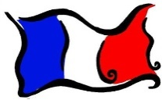  Merci –mer-see

