P4 Home Learning - March/ April2019 Name
 | 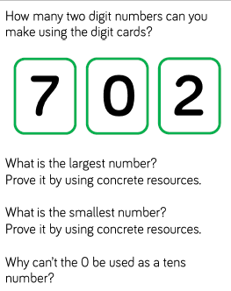 | Practice your 3,7, and 9 times tables  And get someone to test you. Take it in turns to ask a question. | Measure your family.  What height are the members of your family? Who is the tallest? Who is the smallest?
 | 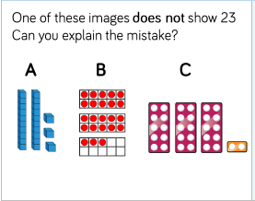 | Can you find and make a list of all the things in your house that can be used to measure something? What unit of measure do they use? | Family Riddle  What has to be broken before you can use it?
MUST DO | Week ending 22nd March –  Read news/newspaper articles  Take notes of anything interesting in the news | Week ending 29th March –  Read adverts -  What tools are the advertisers using toget you to buy something? | By Thursday 4th April –  Read a comic  What makes the comic different from other writing? What’s your favourite and why?
Reading homework - must do – see shaded boxes

You should complete a minimum of three of the other activities by the 4th April We shall share our learing as a class on that day.
If your child wants to, they can than do more of the activities of their choice.

