Name _______________

**P3 February Home Learning**

|  |  |  |
| --- | --- | --- |
| Numeracy  Practise your doubles to 20 and important doubles beyond this, for example, 25, 50 and 100. How quickly can you recall the answers? Take turns to play ‘Quick Fire Doubles’ with an adult at home. | Fractions  Watch the video clip *What are fractions?* on [www.bbc.com/bitesize](http://www.bbc.com/bitesize) then complete the matching activity. Find different things around your home that you can divide up to make fractions, ie. a pizza, a banana, toys, books, etc. and discuss the fractions you have made. | Times Tables    Practise your 2, 5 and 10 times tables and discuss the links between these with an adult at home. Play *2x, 5x and 10x Tables Alien Attack* on [www.snappymaths.com](http://www.snappymaths.com). |
| Writing  The Ancient Egyptians used hieroglyphics as their form of writing. Write a message in code using hieroglyphics. Bring this in to school for one of your classmates to solve! | Spelling  Practise your Fry’s Common Words using one of the active spelling activities from over the page.  Image result for spelling clipart  This month please focus on **list 4** words. | Reading  Choose a book that you have read recently and design a new cover for it. Remember to include the title and the author. You could add the illustrator if you know who it was. |
| Building Resilience  We have been learning that relationships are important for our health and wellbeing and that good relationships are a two-way thing. We should all have a back-up team. Use drawings or photos to create a team picture for the front of your Team Shirt. | Egyptians Class Talk  Choose an area of interest relating to the Ancient Egyptians (ie. Pharaohs, The Sphinx and Pyramids, Mummies) and carry out some personal research. You will then present your learning to the class in the form of a class talk. Please be prepared to deliver your talk on Wednesday 27th February. | Healthy Eating  We will be learning about the different food groups and the importance of eating a balanced diet. Take the Eatwell Challenge at <http://www.foodafactoflife.org.uk/5-7-years/healthy-eating/eat-well/> to see how well you know the different food groups. Perhaps you could make a 3D model of the Eatwell Plate? |

What do I do?

You **MUST** complete the **spelling task** and **Egyptians Class Talk**. You can do more tasks if you want to. We will be discussing our home learning in class time so you do not need to hand in completed tasks. Just be prepared to share your learning on

Wednesday 27th February.

Self-Assessment

When you complete a task colour the circle to show how you felt about it. If you don’t have the colours just write

R-A-G.

Red – I found this challenging.

Amber/Yellow – I needed some help.

Green – I’m confident.

Can you

**Fancy Letters**

Write each of your words using fancy writing. Your letters could be **curly** or dotty... or whatever you decide!

**Pyramid Writing**

Write each of your words like a pyramid.

s

so

som

some

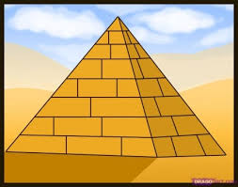



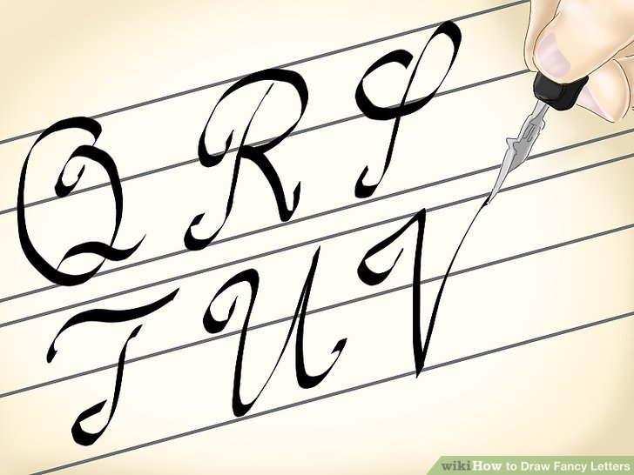

**Alphabetical Order**

Write your words in alphabetical order. Perhaps you could try

writing them in reverse

alphabetical order too?

**Air Writing**

Write your words in the air with your finger. Ask someone to read your words as you write or you could ask someone to air write the letters as you say them to spell your word.

