Name _______________
P3 Sept/Oct Home Learning
Numeracy  Magic squares are a fun way of practising your adding and subtracting. Can you complete the magic squares on the back of this sheet. Can you create your own magic square for someone at home to try?  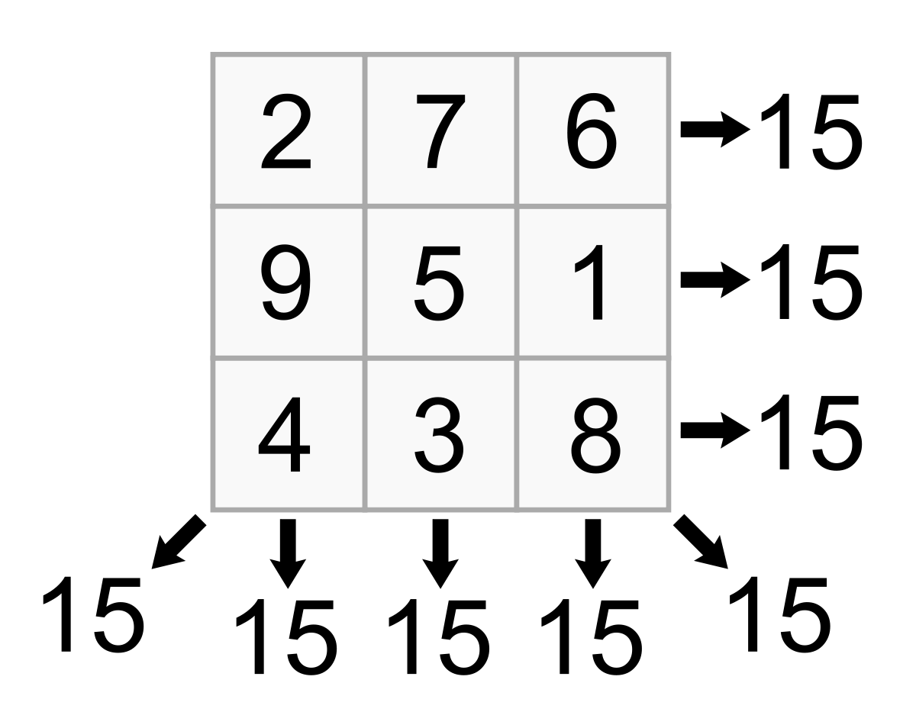 | Symmetry  Symmetry is the mirror image of something. I wonder if you can find examples of symmetry around your house or out in the local environment. Perhaps you could take some photos and bring them in to share with the class.  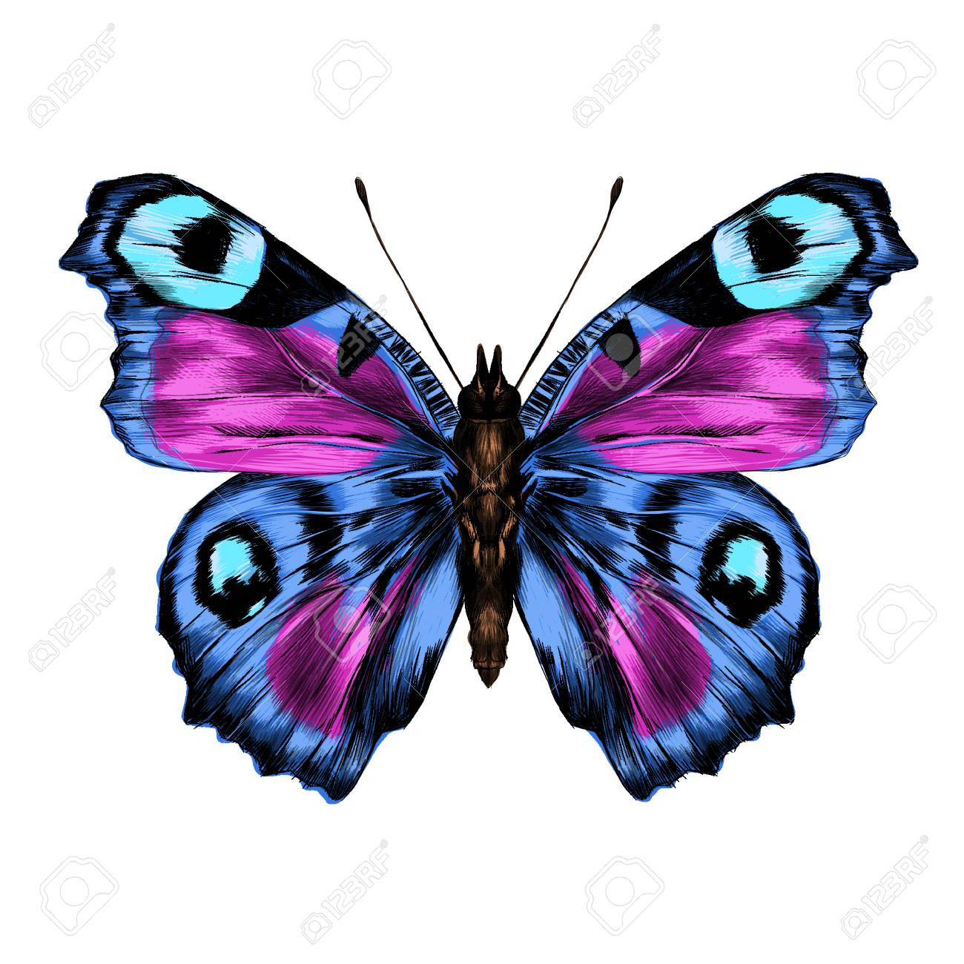 | Place Value  Make digit cards 0-9 and with an adult pick 3 of them. How many different numbers can you make? What’s the largest/smallest number you can make? Can you make an even/odd number? What is the value of each digit in your number?  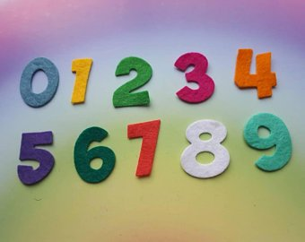
Fact or Opinion?  Facts are based on real events and can be proven. Opinions are people’s thoughts. Discuss the following topics with members of your family. Do you all agree?  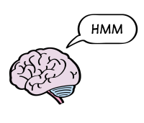  - School uniform should not be compulsory  - Maths is the best subject  - We should not eat animals | Spelling  When we add ‘e’ at the end of a word and it changes the vowel sound from the letter sound to the letter name eg. mad – made, pin – pine, it is called magic ‘e’. Challenge an adult at home, how many magic ‘e’ words can you think of in 5 minutes? Who got the most words? Who got the longest word? Can you write the words in alphabetical order? | In the News  Choose a news item (TV/radio/internet/magazine) that interests you. Can you summarise the main points? Write it down and draw a picture if it helps you to remember.
PE  We have been looking at increasing our fitness levels. Sign up to Go Noodle (it’s free) and have some fun dancing with members of your family. Perhaps you could make up your own dance to teach the class? | New Lanark Visit  Life for Annie MacLeod was very different to the life that you live today. Do some research to find out more about life at New Lanark during the time of Annie MacLeod?  Why was Robert Owen such an influential figure? | Languages  Practise counting forwards and backwards from 0-20 in French. If you’re feeling really confident have a go at counting in 2s (both odds and evens).  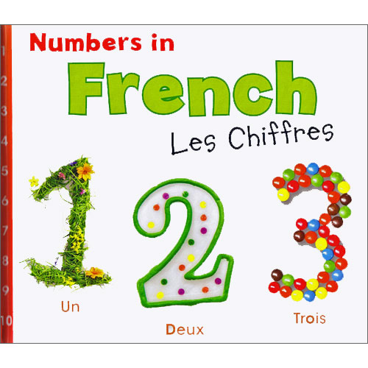  Can you count in another language?
What do I do?
Choose at least one task from each row. You can do more if you want to. We will be discussing our home learning in class time so you do not need to hand in completed tasks. Just be prepared to share your learning on
Thursday 11th October.

Self-Assessment
When you complete a task colour the circle to show how you felt about it. If you don’t have the colours just write
R-A-G.

Red – I found this challenging.
Amber/Yellow – I needed some help.
Green – I’m confident.

Can you

Write the numbers 1 to 9 in each of the squares below, so that each row, column and diagonal adds up to 15.

6 |  |  |  |  | 9 | 2
 | 5
8 |  |  |  | 8

8 |  |  |  | 4
1 | 5 |  |  |  | 5 | 7
 | 7 |  |  |  | 1

