A Parent/Carers Guide to P2

Session 2018-2019

Livingston Village Primary

Miss Whigham & Mrs Fraser

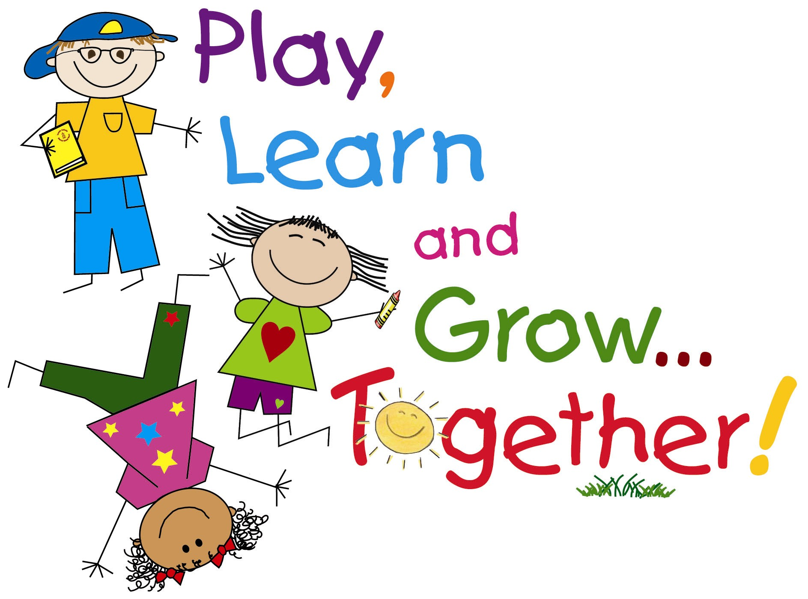

This guide is designed to share with you some information about the curriculum your child will experience this year in P2 as well as providing information about classroom routines and expectations. We hope you find it useful.

English + Literacy
Reading
Children are asked to bring their reading bags each day to school. To allow your child to become more independent, it may help to encourage them to pack their school bag the night before, so that they come prepared each day. Each week your child will receive guided reading sessions with the class teacher (during which their reading homework will be given out in their reading record) and further reading activities which will be completed in small groups, in pairs or independently. This session we will continue to use books from the Read Write Inc resources and Oxford Reading Tree programme. Later in the session we will use the “Fireflies” series which is a non-fiction programme within the Oxford Reading Tree. These books will provide practise of reading skills in a non-fiction context. Children will shortly receive a Reading Strategies prompt sheet which they can keep in their reading bag. We will refer to this sheet often during our guided reading sessions in class and we would ask you to make use of it at home to help your child become a more fluent reader.

Spelling
Children in P2 will continue to use the Read Write Inc programme for weekly spellings and will receive a weekly assessment, normally on a Friday.

Writing
Focused writing lessons will take place once a week. Children will be organised in mixed ability groups and lessons will involve a three group rotation system. Group 1 will work with the class teacher, group 2 will have the support of a Pupil Support Worker and group 3 will work independently. Each week the independent group will have their writing formally marked and feedback will be provided to the children so they are aware of the next steps in their learning. The groups will then rotate round the following week to ensure all children are getting the same amount of time with both adults.

Numeracy + Maths
This session we will continue to use a variety of resources including Number Talk and Big Maths to develop your child’s numeracy and mathematics skills in the three main areas; Number, Money and Measure; Shape, Position and Movement and Information Handling. Children will also develop their problem solving skills through a range of activities and contexts.

Interdisciplinary (Topic Work)
Interdisciplinary will cover aspects of Social Studies, Science and Technology. This term our focus will be The Senses and Keeping Myself Safe with a particular focus on Road Safety and Internet Safety. Where appropriate your child will be taken on educational visits or a visitor will be invited into school.

Throughout the session we will also have a number of Focus Weeks, including Money Week, Scottish Focus and Health and Fitness Focus. The children will also have the opportunity to share their learning by leading two of the whole school assemblies.

Health + Wellbeing
As already mentioned we will begin the session with work on Road Safety and Internet Safety. This will increase the children’s knowledge and awareness of potentially dangerous situations and teaches them strategies that can be applied when their safety is at risk.
By creating a Class Charter children will learn about their rights and also learn about the importance of respecting the rights of others. Pupils will be encouraged to reflect on how their behaviour and actions affect those around them. This will allow us to build and maintain a positive and safe learning environment for all, both in the classroom and around the school grounds. We will be learning the song Be Responsible, Be Safe, Be Respectful by Patty Shukla. Why don’t you listen to it at home too, it can be found by searching youtube for Be Responsible, Be Safe, Be Respectful song or on this link https://www.youtube.com/watch?v=JGQAp2PY8yY.

Class teachers will take pupils for P.E. sessions on Monday, Tuesday and Thursday. We would ask you to ensure your child has a water bottle in school every day as it does get very warm in class and they will require it when they go to P.E. Water bottles should be taken home at the end of each day and refilled ready for the following day. Please note that P.E. kit is black shorts and a plain white t.shirt and this is kept in children’s individual gym bag in school. Please ensure your child has good fitting shoes to enable them to participate fully and safely in this area of the curriculum. It would be helpful if all items of clothing are named, including jackets and shoes. Gym shoes will periodically be sent home for you to assess whether they still fit your child and are still fit for purpose. We would urge you to encourage your child to tell you if they need new gym shoes.

Expressive Arts
Art, Drama and Music will be taught by the class teachers.

Outdoor Learning
This session the school are continuing to develop outdoor learning. Outdoor learning provides excellent opportunities to extend learning which has already taken place in the classroom or to provide additional learning experiences which are not possible within the classroom environment. We would like to ask that you always send your child to school with a jacket so they are prepared should we decide to take our learning outside.

Preparation for Learning
It is extremely important that your child comes to school with the necessary resources to enable them to participate fully in their learning. We would ask that all children have a fully stocked pencil case with pencils, rubber, ruler and sharpener.
We would also like to highlight the importance of arriving in school on time. Please remind children to come into school and organise their belongings quickly so they can have full access to learning time.

Homework
Homework is currently given out on Tuesday and should be returned by Friday. Your child will be given reading, spelling and maths homework on a regular basis. Additional choices of tasks shall be identified that will either consolidate or extend learning already covered in class. Sometimes there will be an extended task which should be completed by everyone, such as a class talk or piece of research and this will be set over a longer period of time. This gives you more flexibility as to when it is done.

Communication
If you have any queries or concerns please do not hesitate to contact us either in person at the end of the school day or by writing a note in your child’s reading record or through an appointment made at the school office. We appreciate your support in working together to enhance your child’s learning and hope that both you and your child enjoy P2!

Thank you for your continued support.

Miss Whigham and Mrs Fraser

