A Parent/ Carers Guide to P1
Session 2018/2019
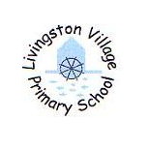
Livingston Village Primary

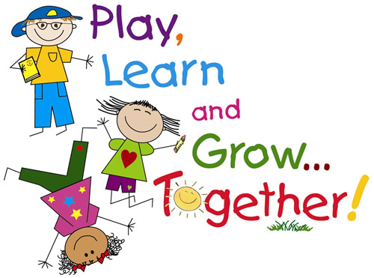

This guide is to share with you some of the things your child will experience this session in P1. I hope you find it helpful.

Homework
Phonics and numeracy home work will be issued after the September weekend.

Your child will be given letter cards to practice their sounds and they will use these cards to word build. Word building is an important part of learning sounds and spelling patterns. Please support your child in this activity, it should be fun. All sounds and blends are linked to classroom learning.
Maths homework will be sent home on a regular basis and will link to work carried out in class. Sometimes there will be an additional task linked to another area of the curriculum. Occasionally this will be an extended task, such as ‘show and tell’ and will be set over a longer period of time to allow for flexibility.

Reading
Children are asked to bring their homework bags to school every day. To encourage your child to be independent, it may help to allow your child to pack their school bag and homework bag the night before, so that they come prepared each day.
When your child is ready to read the following reading resources will be used Read Write Inc. and the Oxford Reading Tree programme using the Biff, Chip and Kipper stories, Floppy’s phonics and Fireflies books. These will provide your child with practise of reading both fiction and non-fiction texts.
PE
Ms King’s P1’s:Tuesday, Wednesday and Thursday.
Miss Maclachlan: Monday, Tuesday, Wednesday.
Please provide your child with black shorts or leggings/joggers and a white t-shirt.
It would be helpful if all items of clothing are named, including jackets and shoes. Please dress your child in a polo shirt on P.E. days as it is easier for the children to change.
https://blogs.glowscotland.org.uk/wl/livingstonvillageprimaryschool/files/2018/09/LVPS-Window-into-Learning-Term-1.doc

If you have any questions or concerns please contact the school office to speak with your child’s class teacher or catch us at the end of the day.
Thank you for your support.

Miss Maclachlan & Ms King

