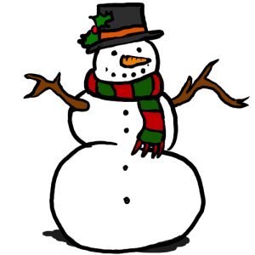
Here is a snow day pack to keep you busy if the school is closed due to heavy snow. Please only do these tasks if the school is closed. Remember to get outside and have some fun too! You can post pictures and comments onto the blog too!
Paper Activities
Click on the Snow Pack to access it at home - SNOW-PACK
Websites
Topmarks
Maths is Fun
Newsround
Scholastic Story Starters
Fun Brain
Brainboxx Problem Solving
Activity Village Christmas Activities
Happy Christmas song
Apps
Advent 2014
Sing Along Christmas Carols
Elf Yourself
Winter Pop
Where is Santa - Santa Tracker

