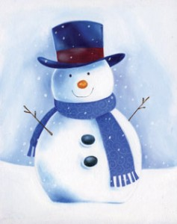
If the school is closed due to snow this winter there are lots of activities that you can do at home instead. I have attached resources and suggested websites that can be used. If you login through Glow you can leave me a comment to tell me how much fun you are having in the snow! Mrs Young has a paper copy in the office for those without computer access.
Please see the websites below for games and activities:
Make a Christmas Card
Happy Christmas song
The Nativity Story
Christmas Maths
Reindeer Singing
The Snowy Day by Ezra Jack Keats
The links below are sheets available to print and use at home
How-many-robins-can-you-see
Letter-to-Santa
Missing-numbersMore-christmas-counting
Reindeer-colouring
Santa-thank-you-letter
snowman-acrostic-poem

