P7 Snow Day Pack
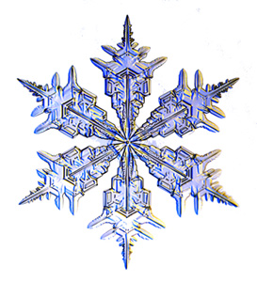

- If you have a snow day off school, first of all get wrapped up then get out and have some snow fun!

- Take photos of what you get up to, write a diary about your activities or make a film.

- Be first to get outside and see if you can make your own snowflake design in the snow, just using your footprints and walking around very carefully. Remember that snowflakes have 6 points.

- Fill a bucket with snow and estimate the volume. Let the snow melt and estimate the volume again. Write an explanation for the difference.

If you can’t get out or need time inside to warm up again, here are some activities you can try. You do not have to do all of them. If you can’t print this off, then just write it out.

- In the song ‘Let it Go’ from Frozen there is a line that says ‘in frozen fractals all around’. Find out what fractals are and have a go at drawing your own.

- Write a Winter poem using personification, similes or alliteration. Go outside and take some photos to give you some inspiration.

- Estimate the volume of snow that has fallen on your garden. You could work it out for the whole plot of land your house is on.

- Find out words for snow in as many different languages as you can.

- Write a list of good things about snow and bad things about snow. Which is longer? Overall, do you think it is a good thing or a bad thing?

- Have a go at making a database of animals that live in the Polar Regions of the world. You can do this on paper, or on a computer if you have access to one.

- Write a questionnaire for your classmates to help you find out what the most popular activities were on the snow day.

- Design a crossword with a winter theme. If you really want a challenge, try to make it symmetrical.

