P6 Snow Pack
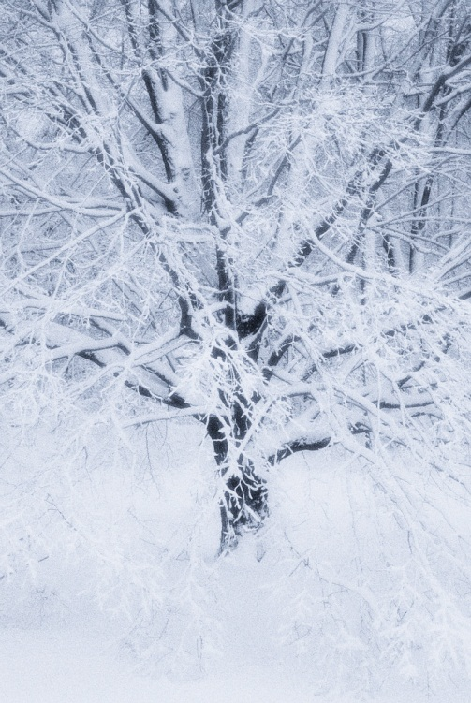
Have fun outdoors.
- Try building a snow family with different heights of snowmen
- Build an igloo out of snow blocks- use an ice cream tub as a mould
- Create targets to fire snowballs at
- If you have a sledge, find a safe slope to sledge down
- Try capturing your fun on your camera or tablet and make a movie about it
- Practise your spelling words by writing with a stick in the snow
- Make an ice sculpture by collecting leaves, cones, berries etc and putting them into an empty jar with some water and a looped ribbon sticking out of the top. Freeze it in the freezer then hang it outside as a decoration
When you have had enough of outdoor fun and need to warm up, write a story or news report about your day. If you create a report, why not film yourself reading it in the style of a newscaster and add footage from outside?
- Look up the weather from around the world. Create a weather map showing the world weather using symbols and a key. Create questions to ask of your map e.g. Where is the coldest place? What is the difference in temperature between the hottest and coldest places?
- Create a poem about a winter’s day
- Look out of the window and sketch the scene you see. Try using pastels or paint if you have them
- Watch a movie and write a review to share with the class when you return to school
- Research an animal that lives in a cold place and create a fact file
- If you have access to a computer or tablet try out some of the websites for some other fun ideas
