# TASK

# Read over the passage below. You be the teacher and write 5 questions and answers for your passage. Write these out in your literacy jotters.

# Suspension Bridges

## What Is a Suspension Bridge?

A suspension bridge uses ropes, chains or cables to hold the bridge. Suspension bridges can cover large distances up to around 2000 metres. Large pillars at either end of the waterways are connected with these cables, and the cables are secured, usually to the ground. Many vertical cables are spaced out along the bridge to secure the deck area. Due to the variety of materials and the complicated design, suspension bridges are very expensive to build.

### Famous Suspension Bridges

The world’s longest suspension bridge is the Akashi Kaikyo Bridge in Japan. This is 2.4 miles long!

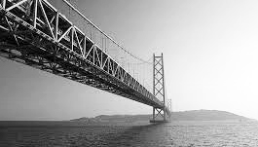

The Clifton Suspension Bridge joins Bristol and North Somerset in England. It was opened over 150 years ago and is kept in good condition by money raised from people crossing the bridge and visiting the site.

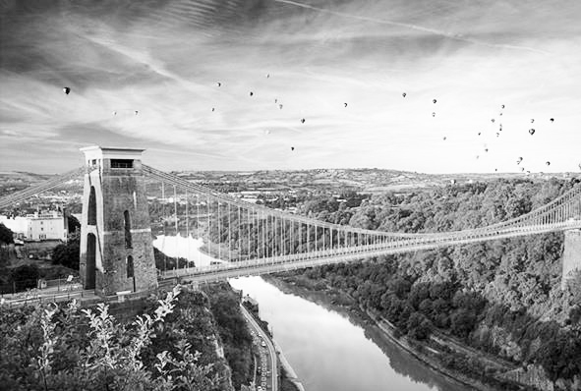

### Did You Know…?

Modern suspension bridges use thin pieces of steel twined together to make a strong cable. The Golden Gate Bridge in San Francisco uses 80,000 miles of cable!

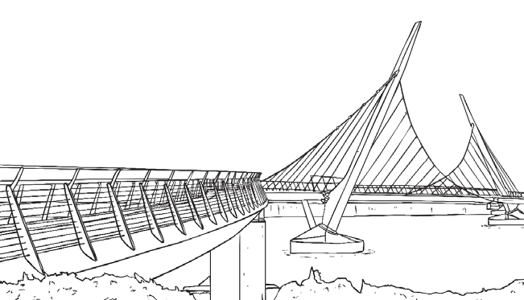

#### Other Suspension Bridge Facts

It is believed that the first ever suspension bridges were made from twisted pieces of grass over 500 years ago. These were used to cross gorges!

Suspension bridges made from chains have been known to collapse if only one link of the chain is damaged. For this reason, cable is used in modern bridge design.