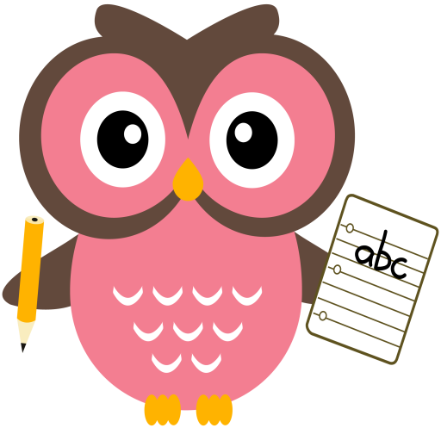

**Maths**

* Please continue to play ‘Fastest Finger to 20’ game, you can download it from the blog.
* Practise keep practising number bonds/pairs to 10 with your child. The children have enjoyed singing our number pairs song in class. It can be found here <https://youtu.be/ch7KzI3n2Zk>
* Click on the link to play Top of the [Classhttp://www.snappymaths.com/addition/make10/interactive/make10totc.htm](http://www.snappymaths.com/addition/make10/interactive/make10totc.htm)
* Download the missing addend activity from the blog, please encourage your child to use the counting on strategy to solve the problems using the number line. We have been using this strategy in class.

**Literacy – Revision Week**

Tricky words this week are, **into**, **here**, **do** and **as.**

Sounds are, **au** and **aw.** Words that we will be building reading and writing this week are: **Paul, maul, haul, saw, raw, law, jaw, lawn, yawn, dawn and paw.**

Although **au** & **aw** are our new sound for this week, **please** keep asking your child to word-build with the consonant blends, th,sh,ch & wh and the rest of the vowel digraphs they have learned so far, ai,ay,ee,ea,igh,y,oi,oy,oo,ew,oa & ow. Some of the children are getting mixed up with sh & ch when we are word-building, please pay particular attention to these blends. Also, some of the children are needing support discriminating between b and d. I’ve uploaded a visual prompt on the blog to help with this.

Please can all reading books be returned on a **Friday**.

Sentences to write: **Some of us are in the red team. We might win the cup if we are good.**

**Home Learning:**

Mon: Sounds – au

Tues: Sounds – aw

Wed: Sounds – au

Thurs: Sounds – aw

Please encourage your child to try and sound out the words or spell the Tricky Words independently, use finger spaces, keep their writing on the line, try to keep letters the same size & to remember capital letters and full stops.

**Term 1**

**2020**

**Comments**

Dear Parents/Carers,

The children all enjoyed receiving their Read, Write, Count Bags on Friday and taking part in the various activities linked to the books through the week. I hope you enjoy looking at the books with your child at home, the parent guide has some great ideas to try at home.

This week you will be receiving home some information about Seesaw, this will be replacing the Online Journals. I will be using this to post homework from next week and any class work for children if they are having to self-isolate. I have been teaching the children how to use it in class and explaining to them how they share their work with me. Please have a look at Seesaw and read the parent guide to become familiar with all its functions. Thank you for your continued support and co-operation,

Mrs Washington