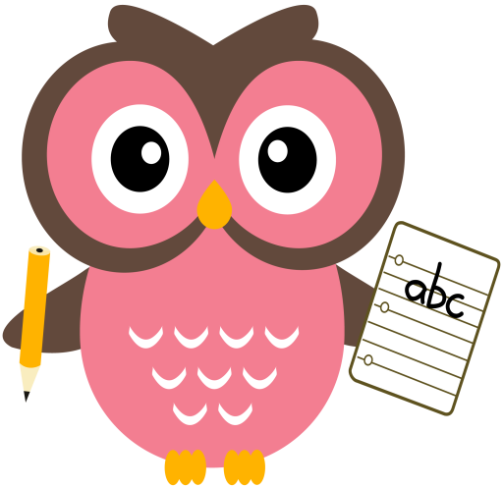

**Maths**

* This week we have been working on our number bonds to 6, for example, 3 and 3, 4 and 2. We have been using counters, Numicon, hangers and pegs, rekenreks and ‘bunny fingers’.
* Practise counting forwards and backwards up to number 30 and beyond if possible and starting at different numbers, not just 1.
* Practise asking questions such as what number comes after/before/ in between a number within 10 and beyond if possible.
* Practise number formation using the jotter and number strip.
* Practise counting amounts up to ten and beyond using 1-1 correspondence for example, buttons or counters.
* Practise download the game **Fastest Finger** **to 10** from the blog and play it with your child.

**Literacy**

Some of the words we will be building this week are- **quack, quick, fox, box, yet, yes, zip, buzz**

**Home Learning:**

**Mon:** sound **‘qu’** tricky word **-want**

**Tues:** sound ‘**x’,** tricky word - **saw**

**Wed:** sound **‘y’** tricky word – **no**

**Thurs:** sound **‘z’**

**Dictation sentence- ‘he was in the fog’**

As well as practising letter formation, please continue to practise number formation. Your child is learning to write lots of new symbols and it is very easy to reverse or form these incorrectly. With lots of practise both at home and school we hope incorrect formation and reversals will soon be a thing of the past!

Things to try-

* Use the laminated number strip then turn it over to practise formation without the visual aids.
* Play number dictation using questions such as ‘write the number after, in-between, one less than/more than etc.

**Term 1**

**2020**

**Comments**

Last week we enjoyed exploring our Bookbug books, we hope you enjoyed reading them at home too. This week you will be receiving home some information about Seesaw, this will be replacing the Online Journals. I will be using this to post homework from next week and any class work for children if they are having to self-isolate. I have been teaching the children how to use it in class and explaining to them how they share their work with me. Please have a look at Seesaw and read the parent guide to become familiar with all its functions.

Thank you for your continued support and co-operation, Mrs Washington