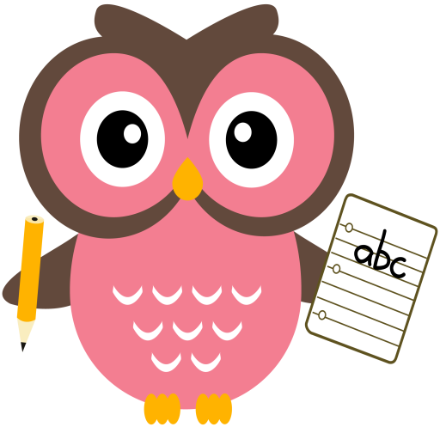

**Maths**

* This week we have been working on our number bonds to 6, for example, 3 and 3, 4 and 2. We have been using counters, Numicon, hangers and pegs, Rekenreks and ‘bunny fingers’.
* Please find the game, **Fastest Finger First** on the blog to help with number sense. Instructions are on the reverse of the sheet.
* Practise counting forwards and backwards up to number 30 and beyond if possible and starting at different numbers, not just 1.
* Practise asking questions such as what number comes after/before/ in between a number within 10 and beyond if possible.
* Please keep practising number formation using the jotter and number strip. Number 3 and 7 are still being reversed quite often and number 9 is often formed incorrectly.

**Literacy**

Some of the words we will be building this week are- **quack, quick, fox, box, yet, yes, zip, buzz**

**Home Learning:**

**Mon:** sound **‘qu’** tricky word **-want**

**Tues:** sound ‘**x’,** tricky word - **saw**

**Wed:** sound **‘y’** tricky word – **no**

**Thurs:** sound **‘z’**

**Dictation sentence- ‘he was in the fog’**

As well as practising letter formation, please continue to practise number formation. Your child is learning to write lots of new symbols and it is very easy to reverse or form these incorrectly. With lots of practise both at home and school we hope incorrect formation and reversals will soon be a thing of the past!

Things to try-

* Use the laminated number strip then turn it over to practise formation without the visual aids.
* Play number dictation using questions such as ‘write the number after, in-between, one less than/more than etc.

**Term 2**

**2020**

**Comments**

Last week we enjoyed exploring our Bookbug books, we hope you enjoyed reading them at home too. Our thoughts are now turning to Christmas and we are beginning to plan our events to ensure Christmas is a special time at LBPS. Please look out for information regarding our programme of events in your emails.