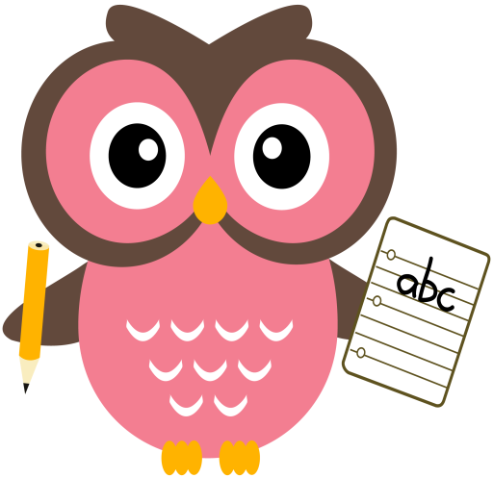

**Literacy**

Some of the words we will be building this week are- **jam, jar, jog, van, vet vick, wet, web, win**

**Home Learning:**

**Mon:** sound **‘j’** tricky word **-his**

**Tues:** sound ‘**v’,** tricky word - **put**

**Wed:** sound **‘w’** tricky word - **was**

**Dictation sentence- ‘sam cut the log’**

As well as practising letter formation, please continue to practise number formation. Your child is learning to write lots of new symbols and it is very easy to reverse or form these incorrectly. With lots of practise both at home and school we hope incorrect formation and reversals will soon be a thing of the past!

Things to try-

* Use the laminated number strip then turn it over to practise formation without the visual aids.
* Play number dictation using questions such as ‘write the number after, in-between, one less than/more than etc.

**Maths**

* We have been working on our number bonds to 5, for example, 2 and 3, 4 and 1. We have been using counters, Numicon, hangers and pegs and ‘bunny fingers’
* Practise counting forwards and backwards up to number 30 and beyond if possible and starting at different numbers, not just 1.
* Practise asking questions such as what number comes after/before/ in between a number within 10 and beyond if possible.
* Practise number formation using the jotter and number strip.
* Practise counting amounts up to ten and beyond using 1-1 correspondence for example, buttons or counters.
* Practise estimating groups of objects then count using 1-1 correspondence to check.

**Term 2**

**2020**

**Comments**

Thank you very much for all your donations for Children in Need! Lovely to see the children all dressed for the occasion and we had a fun filled morning.

Next week it is Book Week Scotland and your child will receive their Bookbug bag which contains 3 fantastic books and other resources to help inspire a love of reading, writing and counting. We will be doing a range of exciting activities with the books next week and on Friday the Bookbug bag will come home with your child. One of the books is called Birds which has beautiful illustrations and information about our native birds. We have included a bird spotting dial on the blog page which can be used to help spot birds in your garden. If you find any we would love to know so please do send us some photos. Please email them into the school office **wllinlithgowbridge-ps** we hope to create a bar graph/pictogram in class with the results.

Thank you, Mrs Washington