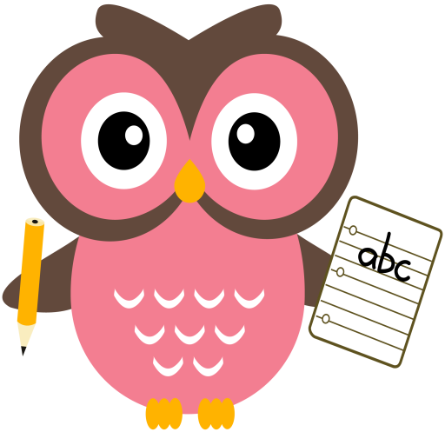

**Maths**

* Say aloud a word problem to your child, for eg, I have 7 apples and I buy 3 more. How many apples do I have now? Can they identify if it is an addition/subtraction problem? Can they write the number sentence to go with it, for eg, 7+3=10? Can they create their own addition/subtraction word problems?
* Practise keep practising number bonds to 10 with your child. The children have enjoyed singing our number bonds to 10 song in class. It can be found here <https://youtu.be/lD9tjBUiXs0>
* Click on the link to play Hit the Button***, please choose number bonds to 10.*** <https://www.topmarks.co.uk/maths-games/hit-the-button>
* Download Fastest Finger game from the blog.

**Literacy – Revision Week**

Tricky words this week are, **were** and **there.**

Sounds are, **ou** and **ow.** Words that we will be building reading and writing this week are: **shout, mouth, loud, south, owl, town, down and cow.**

Although **ou** & **ow** are our new sound for this week, **please** keep asking your child to word-build with the consonant blends, th,sh,ch & wh and the rest of the vowel digraphs they have learned so far, ai,ay,ee,ea,igh,y,oi,oy,oo,ew,oa & ow. These sounds are **very** tricky and the children would benefit from frequent over-learning. I will be assessing the children at the end of the block in a couple of weeks.

Please can all reading books be returned on a **Friday**.

Sentences to write: **It is a hot day. Joy and I are at the beach. We look for fish in the sea.**

**Home Learning:**

Mon: Sounds – ou

Tues: Sounds – ow

Wed: Sounds – ou

Thurs: Sounds – ow

Please encourage your child to try and sound out the words or spell the Tricky Words independently, use finger spaces, keep their writing on the line, try to keep letters the same size & to remember capital letters and full stops.

**Term 1**

**2020**

**Comments**

Dear Parents/Carers,

Thank you very much for all your donations for Children in Need! Lovely to see the children all dressed for the occasion and we had a fun filled morning.

Next week it is Book Week Scotland and your child will receive their ‘Read, Write, Count bag which contains 2 fantastic books and other resources to help inspire a love of reading, writing and counting. Please keep playing the Hit the Button (see above) game, this will help the children to develop fluency and automaticity in their knowledge of number bonds to 10. I’ve uploaded a game called ‘Fastest Finger’ to consolidate numbers to 20. Please can you download it from the blog (instructions are included). We have been playing it in class and the children are really enjoying it and becoming much more familiar with numbers to 20.

Thank you for your continued support and co-operation,

Mrs Washington