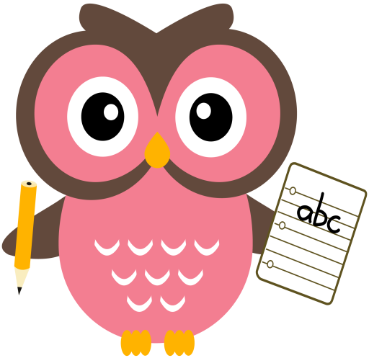

**Maths**

* Say aloud a word problem to your child, for eg, I have 7 apples and I buy 3 more. How many apples do I have now? Can they identify if it is an addition/subtraction problem? Can they write the number sentence to go with it, for eg, 7+3=10? Can they create their own addition/subtraction word problems?
* Practise counting forwards in 2’s to 20 and in 5’s 10’s to 100. Copy the link to practise counting in 2’s to 100 with Jack Hartman. https://youtu.be/OCxvNtrcDIs
* Click on the link to play Hit the Button***, please choose number bonds to 10.*** <https://www.topmarks.co.uk/maths-games/hit-the-button>
* Download stars number bonds to 10 activity from the blog for your child to complete.

**Literacy – Revision Week**

Tricky words this week are, **her** and **of.**

**The children have the new block of laminated Tricky Words in their bag.**

Sounds are, **oi** and **oy.** Words that we will be building reading and writing this week are: **foil, boil, coil, soil, join, toy, boy and joy.**

Can your child create any of their own sentences for any of the words above?

Please can all reading books be returned on a **Friday**.

Sentences to write: **Beth had a new red bow. Her mum put it in her hair.**

**Home Learning:**

Mon: Sounds – oi

Tues: Sounds – oy

Wed: Sounds – oi

Thurs: Sounds – oy

Please encourage your child to try and sound out the words or spell the Tricky Words independently, use finger spaces, keep their writing on the line, try to keep letters the same size & to remember capital letters and full stops.

**Term 1**

**2020**

**Comments**

Dear Parents/Carers,

We have to keep the windows in the classroom open to ensure adequate ventilation, please can all children come to school with plenty of layers on now the weather is getting colder. Please keep continuing to say aloud numeracy word problems and encourage your child to determine if they are addition/subtraction problems, encourage them to write it in a number sentence and for added challenge encourage them to create their own. The Hit the Button (see above) game will help the children to develop fluency and automaticity in their knowledge of number bonds to 10, please encourage your child to play this game.

Thank you for your continued support and co-operation,

Mrs Washington