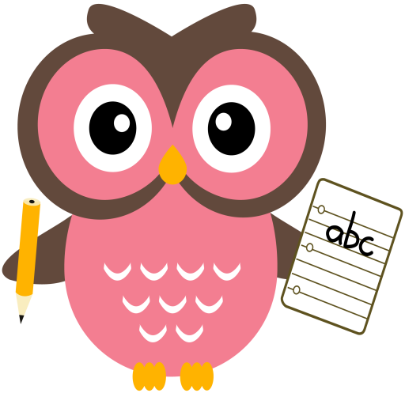

**Literacy**

Some of the words we will be building this week are,

**bed, bad, bud, sock, duck, tick, lad, fog, fig**

**Home Learning:**

**Mon:** We are learning to

**Tues:** identify the 5 vowels and

**Wed:** explain why they are important.

*Please click on the following link to take you to a short/long vowel song.*

<https://youtu.be/PNwj2_q1ypk>

**Dictation sentence- ‘he met a fat hen’**

**Sounds ‘b’ and ‘d’ are very easy to muddle up when writing. We have added a prompt card onto the blog to help if your child needs it.**

**Please practise reading and writing tricky words- Games you can play are- pairs, bingo, drawing on backs or hands, making with playdough, painting tricky words and making them with sticks/stones.**

**Maths**

* We have been working on ‘one more than/less than’ numbers to 10 and beyond.
* Practise counting forwards and backwards up to number 30 and beyond if possible and starting at different numbers, not just 1.
* Practise asking questions such as what number comes after/before/ in between a number within 10 and beyond if possible.
* Practise number formation using the jotter and number strip.
* Practise counting amounts up to ten and beyond using 1-1 correspondence for example, buttons or counters.
* Practise estimating groups of objects then count using 1-1 correspondence to check.

**Term 1**

**2020**

**Comments**

We have almost learned all of the letters of the alphabet! This week we aim to consolidate, revise and revisit prior learning to ensure letter formation/identification, word building/blending/reading and writing is secure.

Thank you, Mrs Washington