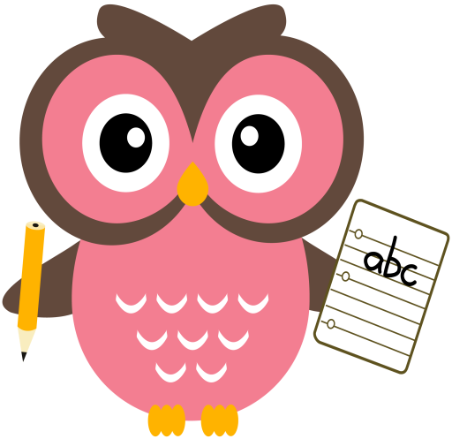

**Maths**

* Say aloud a word problem to your child, for eg, I have 7 sweets and my friend gives me 3 more. How many do I have now? Can they identify if it is an addition/subtraction problem? Can they write the number sentence to go with it, for eg, 7+3=10? Can they create their own addition/subtraction word problem?
* Practise counting forwards in 2’s to 20 and in 5’s 10’s to 100. Copy the link to practise counting in 2’s to 100 with Jack Hartman. https://youtu.be/OCxvNtrcDIs
* Click on the link to play the save the whale game below, to consolidate number bonds to 10.<https://www.ictgames.com/saveTheWhale/index.html>
* Please see number bonds game to 10 on the blog.

**Literacy – Revision Week**

Tricky words this week are, **one** and **you.**

Sounds are, **oo** and **ew.** Words that we will be building reading and writing this week are: **foot, tool, pool, look, cook, hook, boo, shoo, root, chew, new, pew and few.**

Can your child create any of their own sentences for any of the words above?

Please can all reading books be returned on a **Friday**.

Sentences to write: **You and I can feed the hen. Meg might feed the duck.**

**Home Learning:**

Mon: Sounds – oo

Tues: Sounds – ew

Wed: Sounds – oo

Thurs: Sounds – ew

Please encourage your child to try and sound out the words or spell the Tricky Words independently, use finger spaces, keep their writing on the line, try to keep letters the same size & to remember capital letters and full stops.

**Term 1**

**2020**

**Comments**

Dear Parents/Carers,

It was so lovely to speak to you all last week and let you know how well your child is getting on in P2. Please keep encouraging your child to use their laminated name card and letter formation sheet to practise their writing. I am noticing a huge difference in class when the children are writing, thank you for your support with this. Please encourage your child to listen to numeracy word problems said aloud, please see above for more information. All the children need further practise in listening to word problems and determining if they are addition/subtraction problems, writing them in a number sentence and for added challenge please encourage them to create their own.

Thank you for your continued support and co-operation,

Mrs Washington