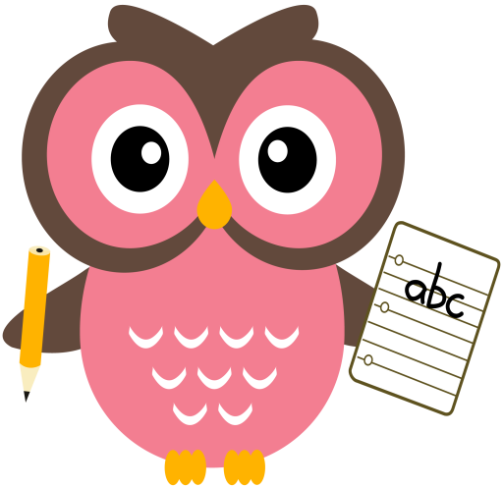

**Maths**

* We have added another numeracy home learning grid to the blog page with additional ideas.
* We have been working on ‘one more than/less than’ numbers to 10 and beyond.
* Practise counting forwards and backwards up to number 30 and beyond if possible and starting at different numbers, not just 1.
* Practise asking questions such as what number comes after/before/ in between a number within 10 and beyond if possible.
* Practise number formation using the jotter and number strip.
* Practise counting amounts up to ten and beyond using 1-1 correspondence for example, buttons or counters.
* Practise estimating groups of objects then count using 1-1 correspondence to check.

**Literacy**

Please cut out the sounds and words below. Words we are building this week are- **lap, lip, pal, cat, cup, can, kick, back, duck, pick**

**Home Learning:**

**Mon:** sound **- l,** word-**he**

**Tues:** sound – **c**, word - **me**

**Wed:** sound – **ck**, word – **is**

**Please practise reading and writing tricky words - games you can play to consolidate the tricky words are - pairs, bingo, writing the words on your child’s back, can they identify them? Making the words with playdough, painting tricky words and making them with sticks/stones.**

**Term 1**

**2020**

**Comments**

Hello, it was lovey to finally speak with you all last week. Winter weather is on its way and we have the windows open in the classroom all the time, please can we ask that your child has lots of layers on to help keep them cosy. Donations of tissues always greatly received. Thank you. Mrs Washington