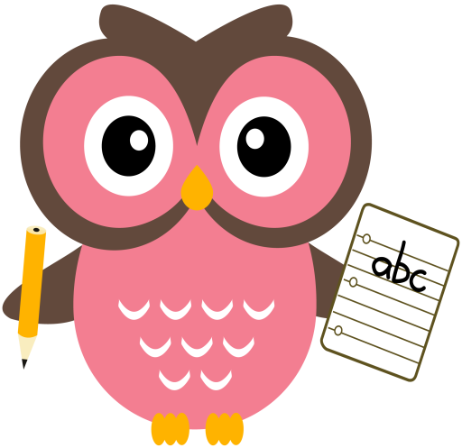

**Literacy – Revision Week**

Tricky words this week are, **some** and **said.**

Sounds are, **oa** and **ow.** Words that we will be building reading and writing this week are: boat, goat, foam, road, coat, moan, row, sow, bow, mow and low.

Please continue to practise reading and writing all the tricky words at home. The children need to keep practising the pink words too. This will help the children to transfer their knowledge into their daily writing and weekly dictation activities. It will also enable them to read with accuracy and fluency.

Please read the sentences aloud to your child and ask them to write them at home.

Sentences to write: **Kay got wet in the rain. She might need some hot tea.**

**Home Learning:**

Mon: Sounds – oa

Tues: Sounds – ow

Wed: Sounds – oa

Thurs: Sounds – ow

Please encourage your child to try and sound out the words or spell the Tricky Words independently, use finger spaces, keep their writing on the line, try to keep letters the same size & to remember capital letters and full stops.

**Maths**

* Practise counting forwards to 100 and beyond, and **backwards** from 30. Try to start and stop at different numbers in the range. For example, 8-15, 19-27, 33-38, 44—53, 29-22, 21-15.
* Practise counting forwards in 2’s to 20 and in 5’s 10’s to 100.
* Click on the link to play the game below, select bonds to 10. <http://www.ictgames.com/mobilePage/funkyMummy/index.html>
* Please see ‘Make Ten’ card game and instructions on blog.

**Term 1**

**2020**

**Comments**

Dear Parents/Carers,

I hope you all had a fantastic October break and I’m looking forward to chatting with you at the Parent Consultation appointments on Tuesday and Wednesday.

The children have all been given a laminated name card with their first & second names to take home for them to practise writing their full name. Please keep it at home as I have made copies for the children to have one in class also. We are also continuing with some estimation work in numeracy, please encourage your child to estimate different amounts of small objects (up to 30) such as; buttons, pasta, sweets or Lego bricks. Once they have said their estimation, they can check. Can they use the materials/resources to count up in 2’s, 5’s or 10’s? Thank you for your continued support and co-operation,

Mrs Washington