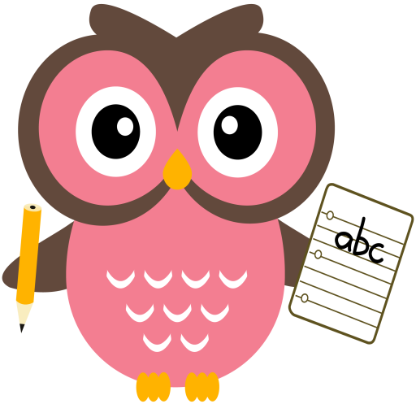

**Maths**

* I have added another numeracy home learning grid to the blog page with additional ideas.
* We have been working on ‘one more than/less than’ numbers to 10 and beyond.
* Practise counting forwards and backwards up to number 30 and beyond if possible and starting at different numbers, not just 1.
* Practise asking questions such as what number comes after/before/ in between a number within 10 and beyond if possible.
* Practise number formation using the jotter and number strip.
* Practise counting amounts up to ten and beyond using 1-1 correspondence for example, buttons or counters.
* Practise estimating groups of objects then counting to check using 1-1 correspondence.

**Literacy**

Please cut out the sounds and words below. Words we are building this week are- **fan, fog, for, sum, mud, bus, bag, bun, bed, rub**

**Home Learning:**

**Mon:** sound **- f,** word-**I**

**Tues:** sound – **u**, word - **the**

**Wed:** sound – b, word – **to**

**Please use the laminated letter sheet and jotter to practise letter formation and name writing. The rhymes we use in class are on the blog page. We encourage the children to say the rhyme as they write the sound as this helps them to remember the correct formation.**

**Term 1**

**2020**

**Comments**

Welcome back, I hope you all had a relaxing holiday? I look forward to meeting with you all on skype this week where I can share with you the learning that has taken place and answer any questions you may have. **Each of the children have been given a laminated name card to help them practise writing their name. Please keep this at home for your child to use as they have another one in class.**

Thank you, Mrs Washington