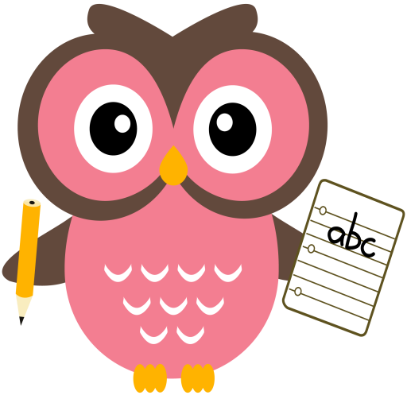

**Maths**

* Practise counting forwards and backwards up to number 30 and beyond if possible and starting at different numbers, not just 1.
* Practise asking questions such as what number comes after/before/ in between a number within 10 and beyond if possible.
* Please see Numeracy Home Learning Wall for extra ideas.
* Practise number formation using the jotter and number strip.
* Practise counting amounts up to ten and beyond using 1-1 correspondence for example, buttons or counters.
* Practise estimating groups of objects then count to check if you are right.

**Literacy**

This week there will be no new sounds to learn as it is a revision and assessment week.

**Home Learning:**

**Mon:** Please practise reading

**Tues:** and writing all words

**Wed:** and sounds covered so far. Thank you

Please see an example of word-building with the sounds on the following clip online.

<https://youtu.be/TkXcabDUg7Q>

**Please encourage your child to use the letter formation sheet that is in their school bags. The letter formation rhymes we use in class have been uploaded to the Blog page. Please encourage your child to say them as they form the letters.**

**Term 1**

**2020**

**Comments**

This week Percy the Park Keeper asked for our help to find out how many apples we have in our orchard and if we could find the heaviest and lightest one. We rose to the challenge and collected lots of apples and we used them to help us subitise, weigh, count and estimate. With careful counting we found out there were 120 apples. There are photos on our school twitter page for you to see. We have continued to estimate using different objects within the classroom and the children are now excellent estimators!