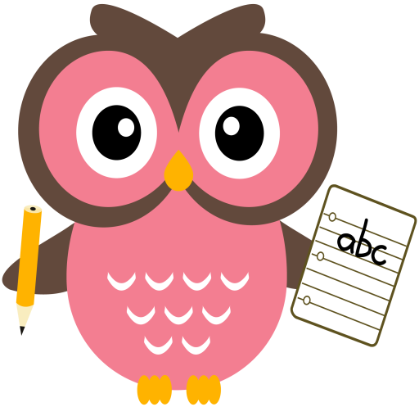

**Maths**

* Practise counting forwards and backwards up to number 30 and beyond if possible and starting at different numbers, not just 1.
* Please see Numeracy Home Learning Wall for extra ideas.
* Practise number formation using the jotter and number strip.
* Practise counting amounts up to ten using 1-1 correspondence for example, buttons or counters.

**Literacy**

We are learning our sounds and how they are formed and are continuing to word build with them. Please cut out the sounds below. Words we are building this week are- **dip, den, hop, get, dig, sad, dog.** (Please see additional sheet on our blog page which has more words).

**Home Learning:**

Mon: Sound – d

Tues: Sound – o

Wed: Sound – g

Please see an example of word-building with the sounds on the following clip online.

<https://youtu.be/TkXcabDUg7Q>

**Term 1**

**2020**

**Comments**

Welcome back, I hope you all enjoyed the sunny September weekend break? This week for some additional number practise, I have given your child a white board pen and laminated number strip to help with number formation.