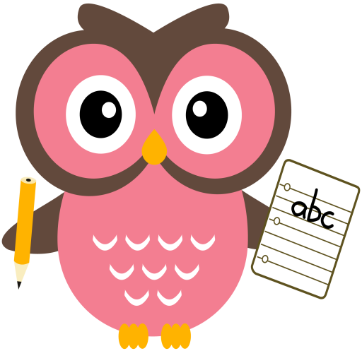

**Literacy**

Tricky words this week are, **some** & **all.**

Sounds are, **igh** and **-y.** Words that we will be building reading and writing this week are: **fight, might, sight, light, night, right, my, why, shy** and **by**.

Each night please keep word-building with the sh/ch/th/wh/ai/ay/ee & ea sounds too, so the children become confident and fluent when blending/ reading words containing these sounds.

Please continue to practise reading and writing all the tricky words at home. Sentences to be read aloud to your child this week are: Sentences to write in jotter: **It is a hot day. We can all play in the sun.**

Please encourage your child to try and sound out the words or spell the Tricky Words independently, use finger spaces, keep their writing on the line, letters the same size & remember capital letters and full stops.

**Home Learning:**

Mon: Sounds – igh

Tues: Sounds – -y

Wed: Sounds – igh

Thurs: Sounds – -y

**Maths**

* Practise counting forwards to 50 and beyond, and **backwards** from number 30. Try to start and stop at different numbers in the range.
* Practise counting forwards in 2’s to 20 and in 5’s 10’s to 100.
* Order numbers 0-30 forwards and backwards. Remove 1 or 2 numbers from the sequence. Can they spot what is missing? Mix up the sequence don’t always start from 0 or 30.
* Please see Numeracy Home Learning Wall for extra ideas.

**Term 1**

**2020**

**Comments**

Dear Parents/Carers,

Please can I ask that **all** reading books be returned on a Friday, I need them to be returned on this day so I can quarantine them before I can issue them to another child. If you could encourage your child to use the letter formation card at least once a week to support their letter formation I would be very grateful.

The children are all working really hard developing number sense of numbers 11-20 in class. Snakes & ladders, dominoes, simple card games such as UNO are activities that would help support this too. Perhaps if you have any of these at home you could play them with your child.

Thank you for your continued support and cooperation,

Mrs Washington