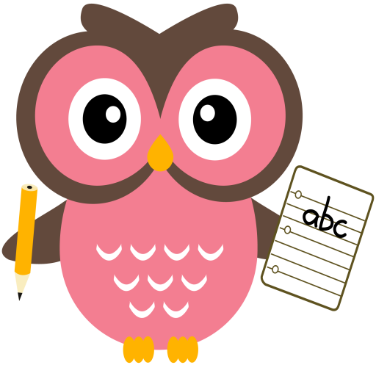

**Maths**

* Practise counting forwards and backwards up to number 30 and beyond if possible and starting at different numbers, not just 1.
* Please see numeracy songs/rhymes on the back of this sheet to sing with your child.
* Please see Numeracy Home Learning Wall for extra ideas.

**Literacy**

We are learning our sounds and how they are formed and are continuing to word build with them. Please cut out the sounds below. Words we are building this week are- **ram, rip, pen, met, hat, hip, ham.** (Please see additional sheet on our blog page which has more words).

**Home Learning:**

We will introduce 3 new sounds per week.

Mon: Sound – r

Tues: Sounds – e

Wed: Sounds – h

Please see an example of word-building with the sounds on the following clip online.

<https://youtu.be/TkXcabDUg7Q>

**Term 1**

**2020**

**Comments**

This week we began reading Percy the Park Keeper Stories. Percy the Park Keeper will write to us each week to ask for help and I’m sure the children will be able to solve lots of problems he may have! We visited our wildlife garden and collected ‘treasures’ we have enjoyed using them in our loose parts play.

I have given your child a little jotter this can be used when practising letter formation, word building, dictation and drawing.



**Ten in the Bed**

There were ten in the bed,   
And the little one said, 'Roll over, roll over'.   
So they all rolled over,   
And one fell out,   
There were nine in the bed…

8…..

7……

6……

5……

4…..

3…..

2…..

There was one in the bed,

And the little one said, 'Roll over, roll over'.

So he rolled over,

And he fell out,

There were none in the bed,

So no one said,

Roll over, Roll over.

**A Tall Silver Rocket**

A tall silver rocket

Is standing on the ground,

Now it’s nearly ready

Here comes the sound.

10,9,8,7,6,5,4,3,2,1

**BLAST OFF**

**Ten Fingers**

I have ten fingers  
And they all belong to me,   
I can make them do things-  
Would you like to see?

I can shut them up tight  
I can open them wide  
I can put them together  
I can make them all hide

I can make them jump high  
I can make them jump low  
I can fold them up quietly  
And hold them just so.