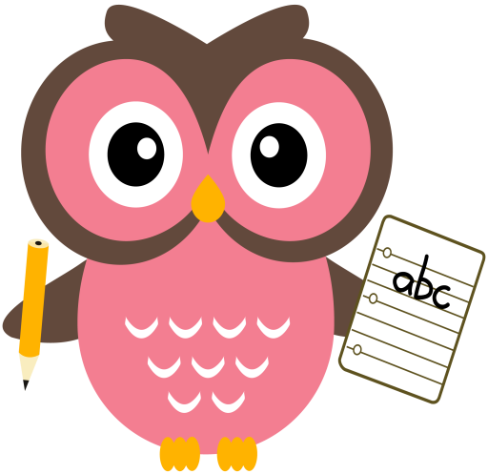

**Literacy**

Tricky words this week are, **they** & **are.**

Sounds are, **ee** and **ea.** Words that we will be building reading and writing this week are: keep, wheel, meet, see, feet, bee, eel, ear, tea, meal, teach, year, reach & eat.

Please continue to practise reading and writing all the tricky words at home. The children need to keep practising the pink words too. This will help the children to transfer their knowledge into their daily writing and weekly dictation activities. It will also enable them to read with accuracy and fluency.

Please read the sentences aloud to your child and ask them to write them at home.

Sentences to write in jotter: **Kim and Val pick the bud. They put it in the jar.**

**Home Learning:**

Mon: Sounds – ee

Tues: Sounds – ea

Wed: Sounds – ee

Thurs: Sounds – ea

**Maths**

* Practise counting forwards to 50 and beyond, and **backwards** from number 30. Try to start and stop at different numbers in the range.
* Practise counting forwards in 2’s to 20 and in 5’s 10’s to 100.
* Order numbers 0-30 forwards and backwards.
* Please see Numeracy Home Learning Wall for extra ideas.

**Term 1**

**2020**

**Comments**

Dear Parents/Carers,

I have noticed a real difference in class this week, when the children have been writing the Tricky Words, thanks for your support with this. The children need to keep revisiting these words so they become embedded into their long term memory, sometimes, it can take a little while for this to happen. This is why we keep revisiting them. We look at our Tricky Words every day in class, discussing the order of the letters, looking at what the first/last sound is, if there are any other Tricky Words hiding in a word and we also look at similarities between the words, for e.g. me/we/be/she all have a long e sounds at the end. Please practise the weekly green words and pick two different pink words for the children to write out too in their jotters. In class, I encourage the children to have a go independently, but if they are struggling I give them a quick 3 second flash of the word to help. Also, this week I gave all the children a laminated letter formation card and whiteboard pen to consolidate the letter shapes, a lot of the children are mixing up b/d, p/q, and i/j or forming some letters backwards or not starting in the correct place when forming letters. Please could they use this card and least once a week to reinforce letter formation. Thank you, Mrs Washington

Thank you for your on-going support & co-operation Mrs Washington

Mrs

Thank you, Mrs Washington

Fiona Washington