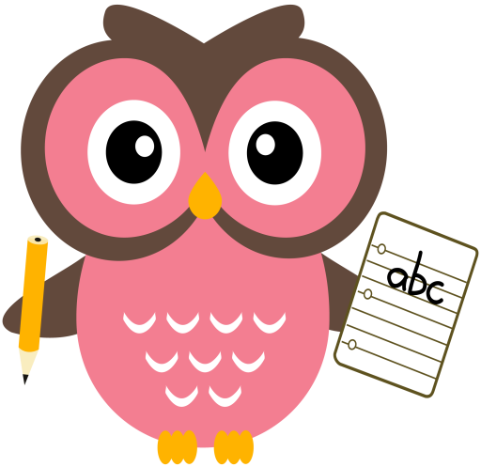

**Literacy**

Tricky words this week are, **be, go we** and **she.**

Sounds are, **ai** and **ay.** Words that we will be building reading and writing this week are: nail, fair, pain, hair, laid, pay, ray, say, day, may and bay.

Please continue to practise reading and writing all the tricky words at home. The children need to keep practising the pink words too. This will help the children to transfer their knowledge into their daily writing and weekly dictation activities. It will also enable them to read with accuracy and fluency.

Please read the sentences aloud to your child and ask them to write them at home.

Sentences to write: **She put the rug in the shed. The bad cat sat on it.**

**Home Learning:**

Mon: Sounds – ai

Tues: Sounds – ay

Wed: Sounds – ai

Thurs: Sounds – ay

**Maths**

* Practise counting forwards to 50 and beyond, and **backwards** from number 30. Try to start at different numbers, not just 1/30/50.
* Practise counting forwards in 2’s to 20 and in 5’s 10’s to 100.
* Order numbers 0-30 forwards and backwards.
* Please see Numeracy Home Learning Wall for extra ideas.

**Term 1**

**2020**

**Comments**

Dear Parents/Carers,

The children have been working really hard in class and have settled back into the routines so well! I have been doing lots of assessments with the children since we all returned to school. Looking at these results I have decided to revise the Block 2, vowel digraphs and Tricky Words with the children, so they have a good knowledge of these before we move on to the next stage in our phonics programme. In particular, all the children would benefit from extra practise **writing** their Tricky Words. This is something we do every day in class and I would really appreciate it if you could do this each night too. Please practise the weekly green words and pick two different pink words for the children to write too.

Thank you for your on-going support & co-operation Mrs Washington

Mrs

Thank you, Mrs Washington

Fiona Washington