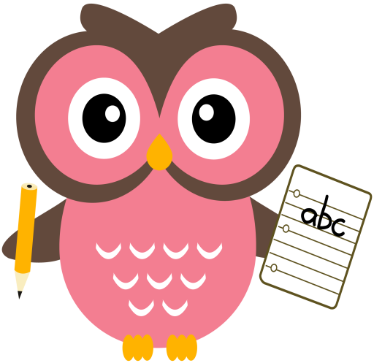

**Maths**

* Practise counting forwards and backwards up to number 30 and beyond if possible and starting at different numbers, not just 1.
* Please see numeracy songs/rhymes on the back of this sheet to sing with your child.
* Please see Numeracy Home Learning Wall for extra ideas.

**Literacy**

We are learning our sounds and how they are formed and are continuing to word build with them. Please cut out the sounds below. Words we are building this week are- **pin, sat, mat, at, sip, tap, ant, man.** (Please see additional sheet on our blog page)

**Home Learning:**

We will introduce 3 new sounds per week.

Mon: Sound – i

Tues: Sounds – s

Wed: Sounds – m

Please see an example of word-building with the sounds on the following clip online.

<https://youtu.be/TkXcabDUg7Q>

**Term 1**

**2020**

**Comments**

Dear Parents/Carers,

We have had a busy and productive start to P1. Your children have all settled in very well and are beginning to manage all the new routines we have in place. They have been making very good progress with their new sounds, each child has their own magnetic board with their sounds and we have been practising word building each day. We have also been making good progress with our numbers, counting, ordering, subitising, sorting and writing.

Thank you, Caroline Marshall and Fiona Washington



**Ten in the Bed**

There were ten in the bed,   
And the little one said, 'Roll over, roll over'.   
So they all rolled over,   
And one fell out,   
There were nine in the bed…

8…..

7……

6……

5……

4…..

3…..

2…..

There was one in the bed,

And the little one said, 'Roll over, roll over'.

So he rolled over,

And he fell out,

There were none in the bed,

So no one said,

Roll over, Roll over.

**A Tall Silver Rocket**

A tall silver rocket

Is standing on the ground,

Now it’s nearly ready

Here comes the sound.

10,9,8,7,6,5,4,3,2,1

**BLAST OFF**

**Ten Fingers**

I have ten fingers  
And they all belong to me,   
I can make them do things-  
Would you like to see?

I can shut them up tight  
I can open them wide  
I can put them together  
I can make them all hide

I can make them jump high  
I can make them jump low  
I can fold them up quietly  
And hold them just so.