Primary 1 Home Learning Work From Miss Hall
Wed 24th June 2020
Hello Primary 1, here we are at the last week of term boys and girls and I’m sure you are all looking forward to your summer holidays. Here are a variety of different activities for you to try today.
To access the Twinkl documents you first have to sign up for a free membership account:
- Go to www.twinkl.co.uk/offer
- Sign up for a free account (entering parent as occupation)
- Enter the offer code UKTWINKLEHELPS
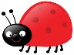
French
I can relearn how to say the numbers 1 to 10 in French with this fun activity.
- Click onto https://www.bbc.co.uk/bitesize/clips/zrdg9j6
- Watch this game and repeat the numbers as they play
- Can you try this hopscotch game outside on your path using French numbers?
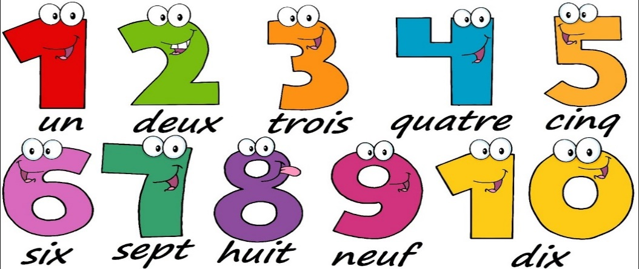

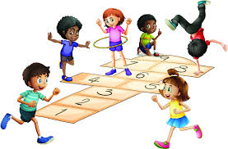
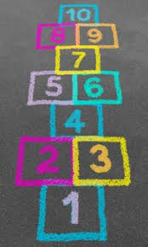

Literacy
I can learn how to write the formation for the Capital M and N letters.
- https://www.twinkl.co.uk/resource/t-l-8548-upper-and-lowercase-letter-formation- Powerpoint
- Scroll down and select the Capital M slide and try this 5 times by clicking onto the pencil
- Now make this letter in the air with your finger, then on the floor 5 times
- Scroll down and select the Capital N slide and try this 5 times by clicking onto the pencil
- Now make this letter in the air with your finger, then on the floor 5 times
- Try writing the Capital letters M and N several times either with paints, in flour, sand or using highlighters
- Play I spy – How many words can you see in your home beginning with the letters M or N?
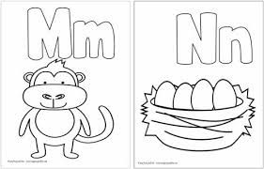
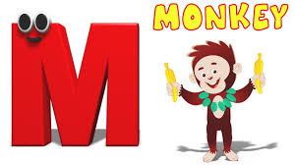
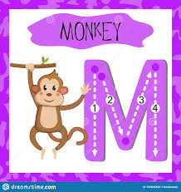
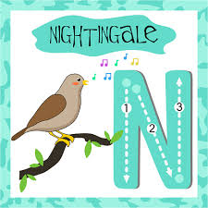

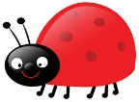
Story and Music Time
I can listen to the story, make predictions and learn new vocabulary.
I can participate and enjoy singing and performing to the music.
- Click onto https://www.youtube.com/watch?v=IGRjRCmtg2M to listen to the story called Fun in the Sun
- Select https://www.youtube.com/watch?v=3F1JLzBdlKs to have fun with The Floss Dance by Jack Hartman

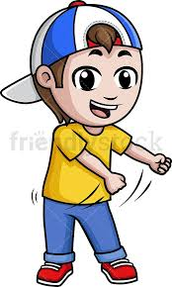
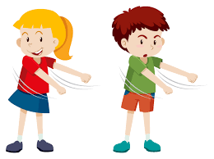

I can explore a variety of different ways of expressing myself by using a selection of art and craft skills.

Summer Art Ideas
Here are some Summer Art Ideas for you to try. Please ask a grown up to help you choose the one you would like to do from the pictures.
- Handprint Ice Cream Cones
- Patterned Ice Lollies
- Pineapple Finger Paints
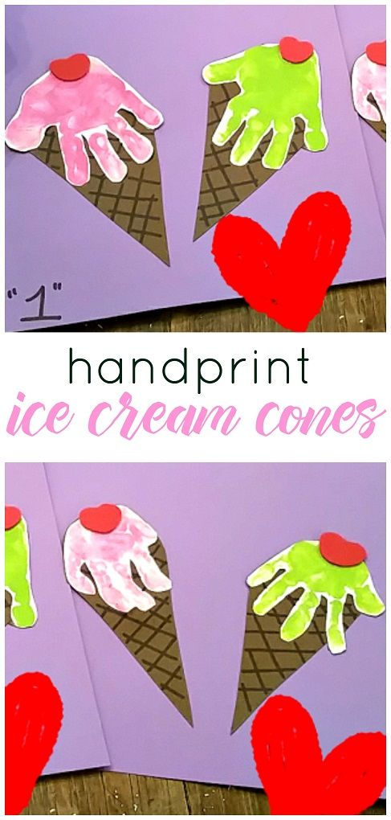
- Foot Print Sandals
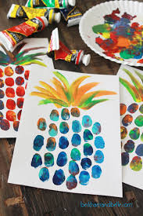
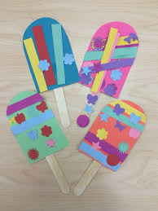

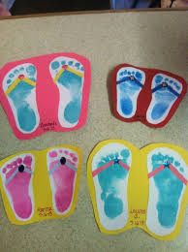

Art Materials You May Need
- Handprint Cones – paper triangle shape, paints and your hand print
- Patterned Ice Lollies – Coloured paper, lolly stick and bits and pieces to decorate
- Pineapple Finger Paints – Colourful paints, white paper and a separate container to dip your fingers into with paint
- Foot Print Sandals – White paper, coloured paints, a separate container big enough for your foot prints and bits and pieces to decorate your sandals
- You will also need scissors and glue for most of the activities
- Remember, you can add pieces of ribbon, material or chalks to your pictures to make them bright and sparkly
Have Fun and Enjoy Yourself!
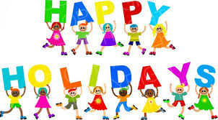
Thank you to you and your families for all your hard work in primary 1. I’ve really enjoyed working with you and I hope you have a wonderful summer holiday together.
Best Wishes from Miss Hall

