Safe 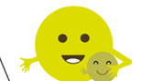  - Draw a picture of how we can stay safe in school when we go back to school.  - Draw a picture/ make a poster of what makes an exciting classroom for learning.  - How can we travel to and from school safely? Make a poster to show this.  - Try this experiment with an adult to see why we wear sun cream:  https://www.playdoughtoplato.com/kids-science-sunscreen-science/  - Look at ways that you can stay safe online  https://www.saferinternet.org.uk/advice-centre/young-people/resources-3-11s | Healthy 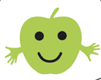  - Talk about the healthiest way to travel to school.  - Create a healthy packed lunch.  - Brainstorm ways we can help each other social distance in the classroom.  - Learn a song that you can wash your hands to for 20 seconds.  - Continue to keep brushing your teeth.  https://www.youtube.com/watch?v=btGqUT2HEKU  - Try some mindfulness tasks- some ideas are attached below. | Achieving 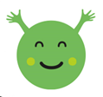  - Choose your favourite piece of work you did during the lock down to bring into school and share with your new teacher.  - Draw/ write about a new skill that you have learned during lockdown.  - If you had a superpower- what would it be? Draw or write your answer.  - Write/draw a bucket list of what you would like to achieve in your next class.  - Set yourself a challenge for when you return to school. Write a plan for the steps you will take to achieve your goal. | Nurtured 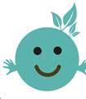  - Draw/ talk to an adult about how you feel about going back to school. What words or a colour could you use to describe how you feel? Why did you pick the word/ colour?  - Worry Jar Task:  Take an empty jar (with a lid) and fill it with your worries. Write each worry on a slip of paper and put it in your jar. Then either discuss each one at a suitable time with someone at home or bring your jar to school when you return and share your worries there. Or write your worries on the jar below and share them as above.  - Random acts of kindness- what kind things could you do for others in your household?
Active 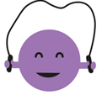  - Design some new toys for the playground  - Create a new playground game.  - Create your own Joe Wicks style work out of 10 different exercises, keep it safe so you can do it as a class when we are back at school.  - Design a new work-out routine. You could include different obstacles using objects in the house.  - Create an outdoor game that you could play at PE or break that takes account of social distancing. Write down or draw the rules and prepare to explain it to your class. | Respected  - Make a tray label/ peg label for going back to school. Remember to write your name clearly.  - Think about what makes a good friend? Draw a flower and write the qualities of a good friend on the petals.  - Think about how you show respect- play the game below.  - Complete the wellbeing grid and reflect on how you are feeling. Note down any reasons why you have given yourself red, amber or green. | Responsible 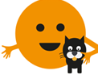  - Draw a picture of some jobs you have done at school or at home  - Design a new bin for the playground.  - Lockdown Memory Jar:  Take an empty jar (with a lid) and fill it with your lockdown memories. Write each memory on a slip of paper, think of a heading for each one and put it in your jar. Make a label for your jar. Or fill in your memories on the jar below and decorate the lid and label.  - Can you set yourself 3 targets you wish to achieve in school by Christmas? | Included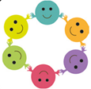  - Design a new school uniform.  - Create a mascot for the school. It could be an animal, object, plant etc.  - Draw a picture of yourself and write key words/ sentences that will tell your new teacher something about you. Include likes/ dislikes.  - Draw or write how you are a good friend to others.

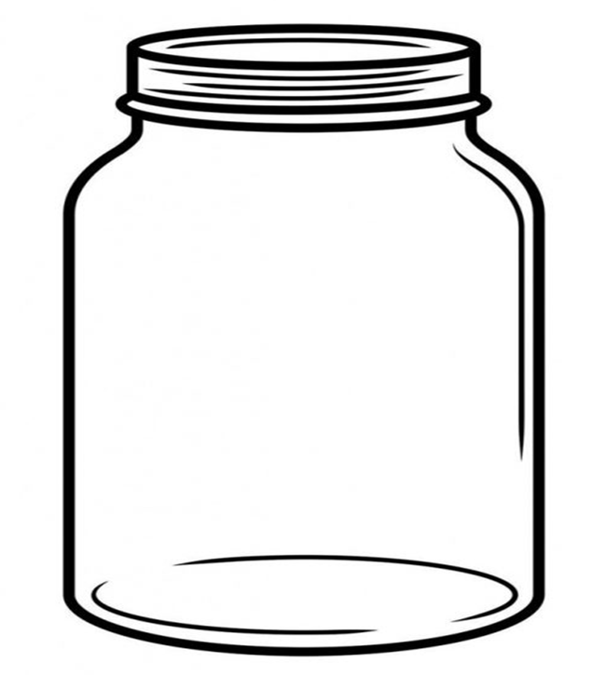
Worry Jar

Lockdown Memory Jar

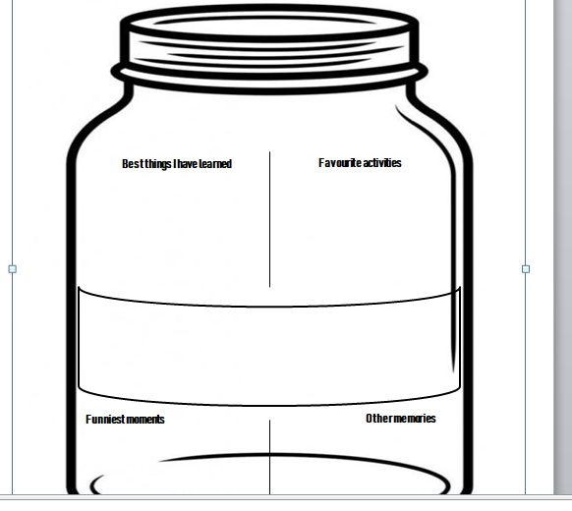

Mindfulness Tasks
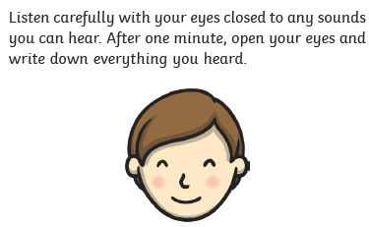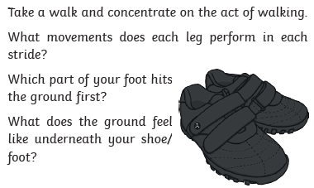
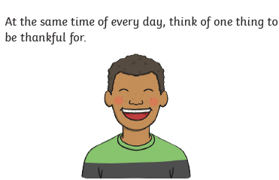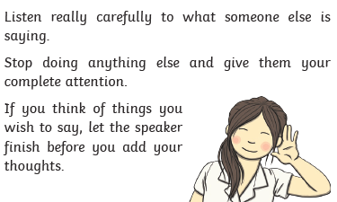

Respect Game
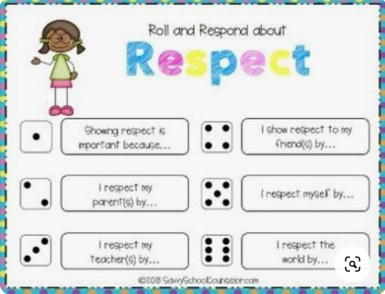

Health and Wellbeing

How am I feeling?

Name:
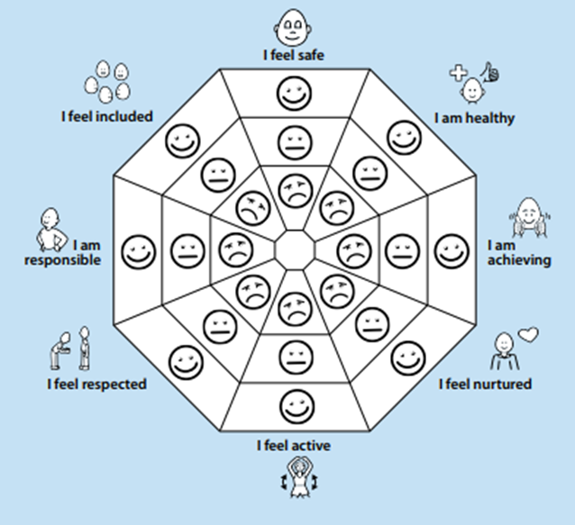
Date completed: _____________________________

