C:\Users\cnewbold6\AppData\Local\Microsoft\Windows\Temporary Internet Files\Content.IE5\P0VTYTKE\OED[1].gif****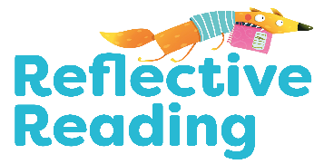

**Which?**

**when?**

**How?**

**Where?**

Create Something Great

**Read and Understand**

Can you talk about what happens in the book in your own words.

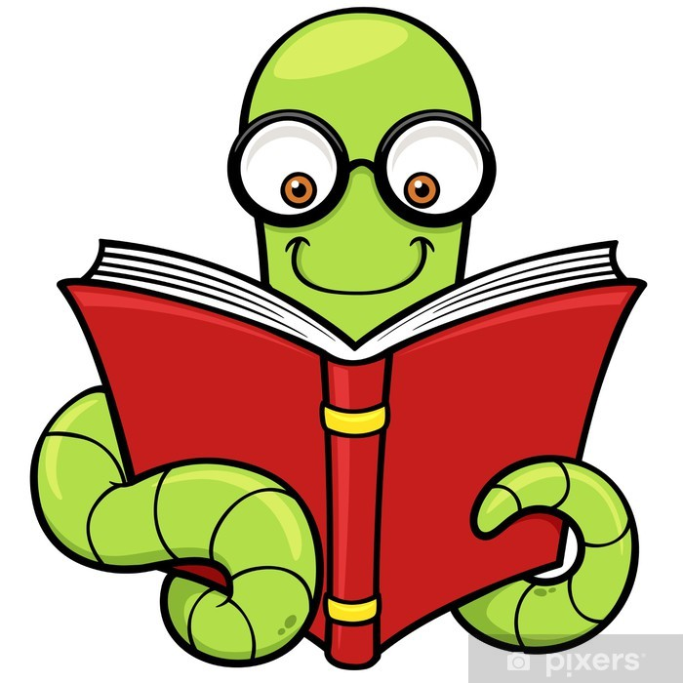

P1 choose a follow-up

Reading task to do

with your book.

Create Something Great

Explore Some More

Reflect and Respond

Infer What’s Not There

Explore Some More

Fiction

Draw a new character that could be in your book.

Non-Fiction

Write and draw a fact from your book.

Can you look for the following punctuation in the book?

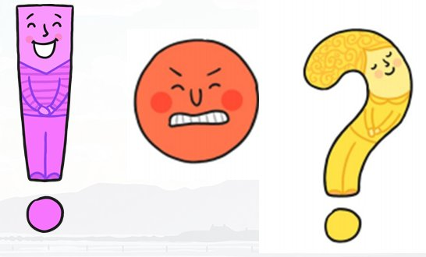

What do they mean?

Create a quiz! What questions could you ask a reader?



What is your favourite part of the book?



Use the front cover to discuss what might happen in the book..

Can you think of another adventure for the character?

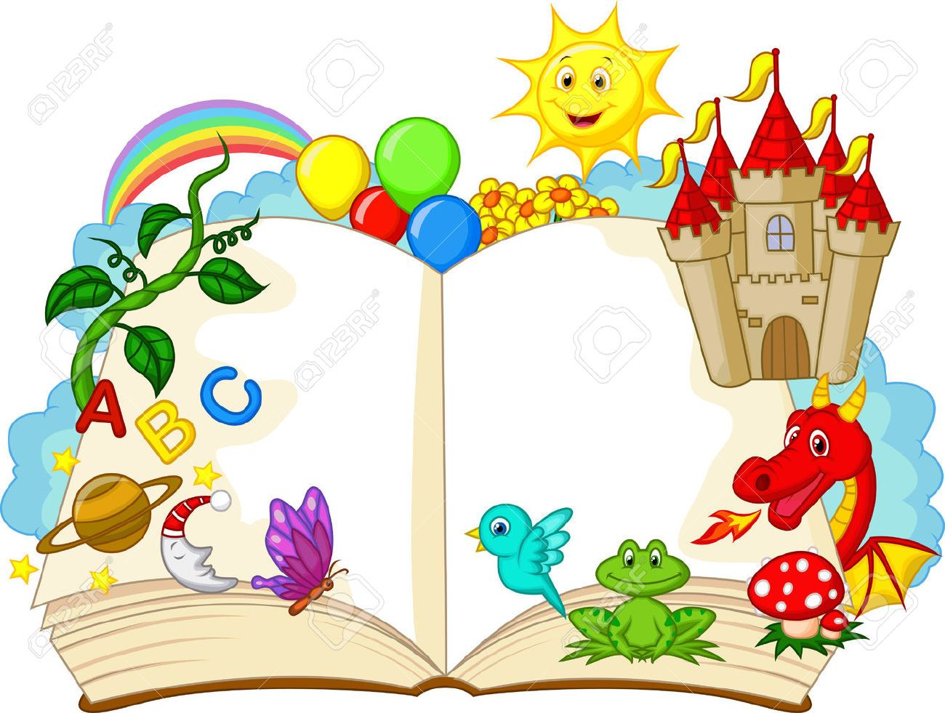

Can you skim and scan your book for some tricky words and make a list.

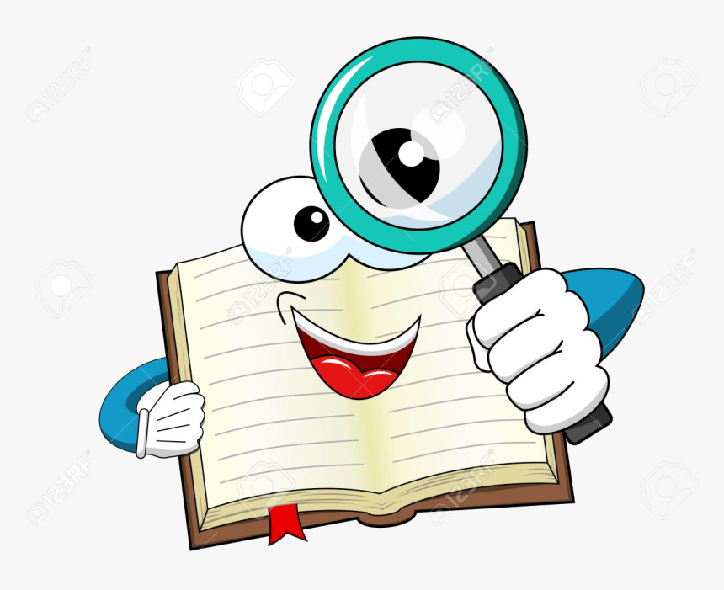

Who is the author of the book?

Who is the illustrator of the book?

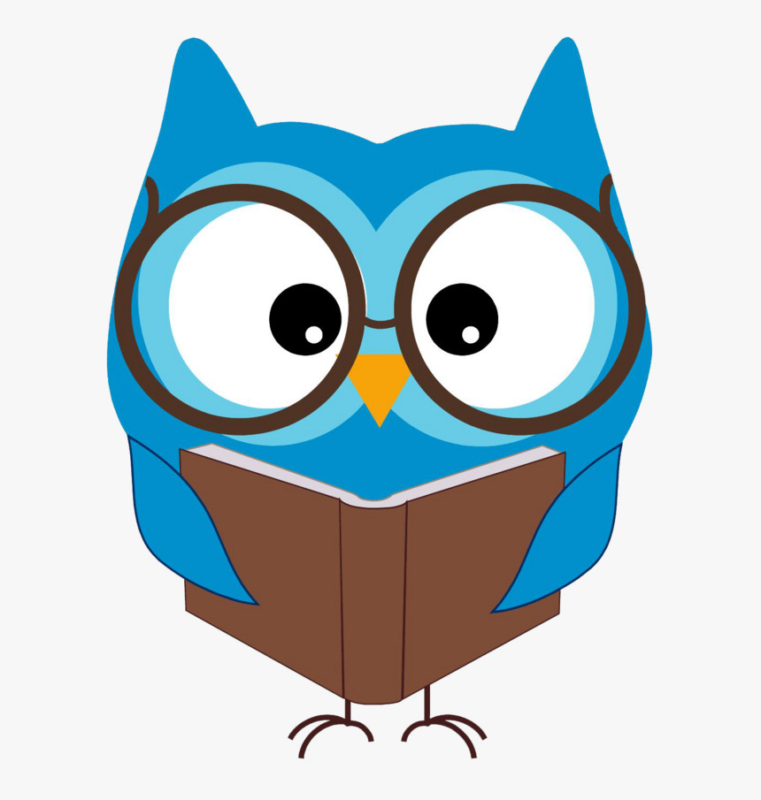

Read and Understand