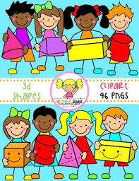
Primary 2 Home Learning Work From Miss Hall
Week 8 Thursday 28th May 2020
Hello Primary 2, here are some activities for you to try today.
To access the Twinkl documents you first have to sign up for a free membership account:
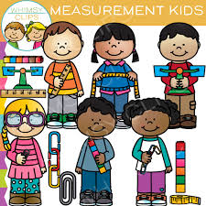
- Go to www.twinkl.co.uk/offer
- Sign up for a free account (entering parent as occupation)
- Enter the offer code UKTWINKLEHELPS

Practical Maths
Learning Intention – I can explore and learn about Measurement and discover a variety of ways to understand and work this out.
- Click on the website https://www.twinkl.co.uk/resource/t-n-45372-jungle-measuring-powerpoint to work on the activities
- https://www.twinkl.co.uk/resource/t-n-2546085-ks1-beanstalk-height-and-length-activity-powerpoint and try some of the ideas
- Click on https://www.topmarks.co.uk/ordering-and-sequencing/coconut-ordering
- Select LENGTH – Up to 20cm then UP to 100cm and enjoy these games
- Use some small items from home or outside like lego, bricks, cubes, small stones, pasta or crayons and try to arrange them in order of size – smallest to biggest, small, medium or large, or tallest to shortest.
- Use these pictures for ideas
- Write these words beside your work – for example, Smallest – Biggest
- Shortest – Longest, or Small, Medium or Large
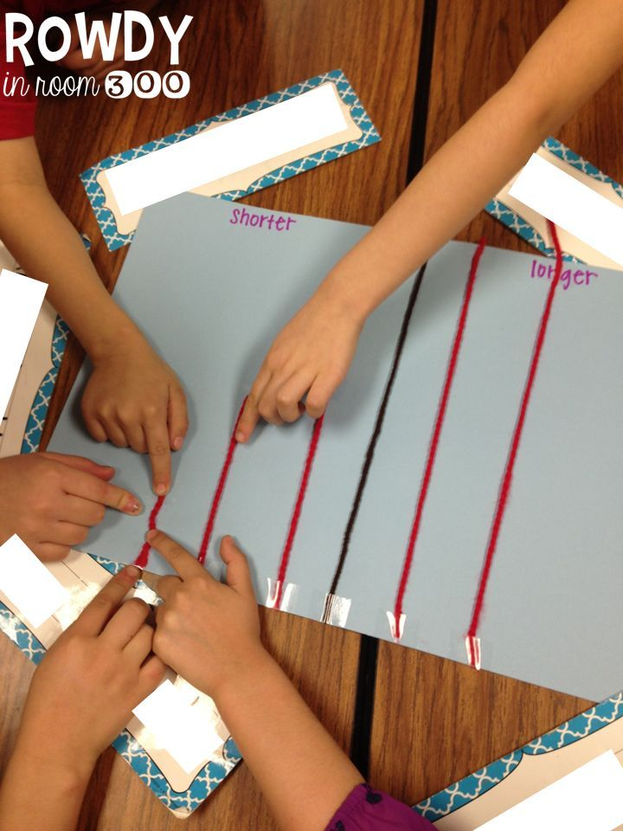
- Think of some of your own ideas too please
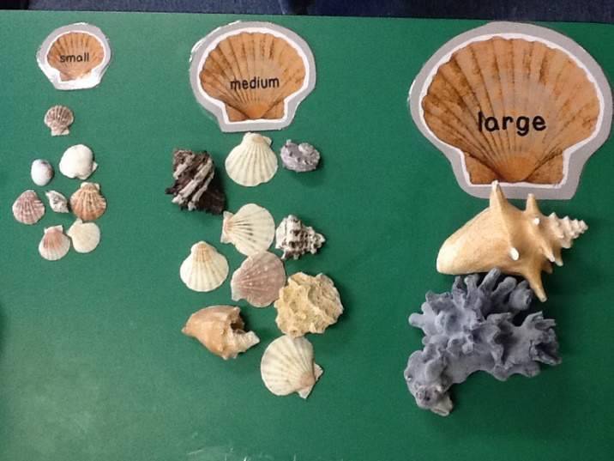
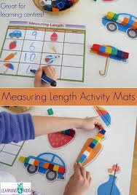

Literacy
Learning Intention – I can revise my Spelling Words and identify the patterns.
wiping gazing smiling diving blaring taping wiring caring sharing biting naming chasing
- Click onto https://www.youtube.com/watch?v=16LFRHqgG9M to listen to the Spelling Rule Song – Drop the ‘e’ add – ing’
- Read each of the words, clap the syllables then use your sound box to sound out the words
- Say each of the words using a loud voice and then say each of them using a quiet voice
Learning Intention – I can learn to understand and recognise what a Verb is and why we use these in our writing.
- Select the website https://www.twinkl.co.uk/resource/t3-e-515-what-are-verbs-powerpoint to look at the ideas
- Click onto https://www.bbc.co.uk/bitesize/topics/zrqqtfr/articles/zpxhdxs and watch how the clip explains what Verbs are and how they are used
- Continue to scroll down and complete the next 2 activities – Highlight the Verbs in each sentence and The Verb Quiz
- Use a newspaper or a magazine and cut out some large individual letters to make 3 of your own Verbs and stick these into your jotter or on paper
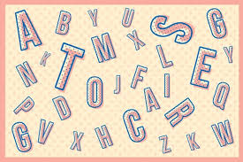
- You can find these kind of letters in the Title or Heading of a story
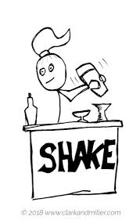
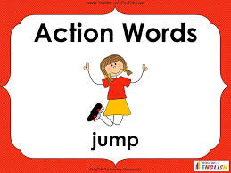

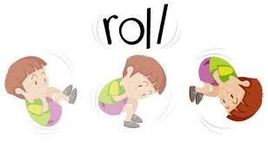

Story Time
Learning Intention - I can listen to the clip, ask questions and learn new vocabulary.
- Click on https://www.youtube.com/watch?v=oBmVO-MlVrk to listen to the story of The Lighthouse Keeper’s Rescue by Ronda and David Armitage
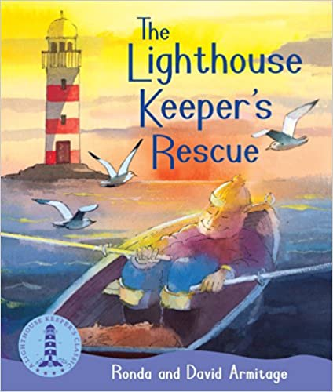

Music
Learning Intention – I can participate and enjoy singing and performing to the music
- Click onto https://www.youtube.com/watch?v=gfa-SnBNbRQ to listen to the song You Can’t Keep a Horse in a Lighthouse

French
I can learn about some simple daily school routines in French with the parrot Papo.
- Click onto https://www.bbc.co.uk/bitesize/clips/zbk3cdm to listen to the ideas and join in with the French words
- Pause the clip each time to repeat each of the French words
- Write down any 4 of these French words from the clip and draw and colour the pictures which match them

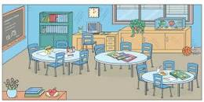
- une regle – ruler
- un crayon – a pencil
- la sale de classe – classroom
- le dejeuner – lunch
- une gomme – a rubber
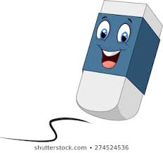

Try these words with your family!
bonjour merci au revoir

